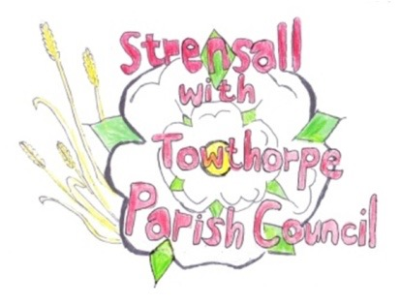
STRENSALL WITH TOWTHORPE PARISH COUNCIL

The Village Hall, Northfields, Strensall, York YO325XW
e-mail: strensalltowthorpePC@outlook.com
phone: 01904 491569
Chairman : Mr A H Fisher

MINUTES OF AN PARISH COUNCIL MEETING HELD IN THE VILLAGE HALL ON THURSDAY 13th DECEMBER 2022 AT 7.15 PM
Councillors Present: Andrew Bolton Tony Fisher** Lawrence Mattinson Susan Nunn Kevin Ogilvy Christopher Tetley
In Attendance: Paul Doughty**

Public Present: 1
** City of York Councillor
- a) To receive apologies for absence given in advance of the meeting: Parish Councillors Chris Chambers and John Chapman* City of York Councillor Paul Doughty
b) To consider the approval of reasons given for absence: *Resolved - Approved (Unanimous)

- To discuss the ordinary and casual vacancies: NTR

- To receive any declarations of interest under the Parish Council Code of Conduct or
Members register of interests: None

- a) To approve the minutes of the Parish Council meeting of 08th November 2022:
Resolved – Approved (Unanimous)
b) To endorse the approved Planning Committee minutes of 08th and 22nd October 2022:
Resolved – Endorsed (Unanimous)

- Public participation on any subject relating to the agenda: Defibrillator @ Manor Park – The Parish Clerk advised that the Parish Council could not help fund a defib on private property, which would not be publicly available.
Dog bin along Pottery Lane – The Parish Clerk would ask CYC if this would be a possibility.
22/61 To receive matters raised by/with City of York Ward Councillors: City of York Council – Improvements to the A1237 York Outer Ring Road (22/02020/FULM) The Parish Council would take a closer look at this application and decide their response at the January 2023 meeting.

22/62 To discuss and, if necessary, agree action on matters arising/ongoing issues: a) North Yorkshire Police monthly reports – The Parish Council noted the content of the November 2022 report
22/63 To discuss and, if necessary, agree action on matters raised since last meeting: a) Remembrance Day - Possible road closure in future The Parish Clerk would research this further with CYC and report to a future meeting.
22/64 To discuss and, if necessary, agree action, on any correspondence received: a) City of York Council – Highways Act 1980 Section 119 diversion Resolved / No Objection (Unanimous) b) Swish Fibre Yorkshire – Strensall Cabinet – West End The Parish Council noted the location of the cabinet c) CML (Network Rail) – Strensall flood alleviation drainage works Resolved / No Objection (Unanimous) Subject to: - the total reinstatement of the area, within one month, of completing the work - the trees are protected, as I understand, some are subject to TPOs - every effort is made to keep to a minimum an disruption to parents/children of the primary school, as this is a main route of the “school run”
22/65 To discuss matters raised by/with Responsible Financial Officer (RFO): a) Bank reconciliation, income received, payments made to date The Parish Clerk had circulated a bookkeeping spreadsheet by email, with bank accounts totalling £200654.68 b) Internal Controls Checks – Cllr Fisher would conduct these in the office tomorrow morning c) Budget/Precept 2023/2024 – The Parish Clerk had circulated an updated draft, which would be discussed at the next meeting. d) Yorkshire Local Councils Association – NTR
22/66 To confirm the date of the next meeting as Tuesday 10th January 2023 at 7.15 p.m.: Resolved – Approved (Unanimous)

Cllr Mattinson gave a very short practical demonstration on the subject of water quality

