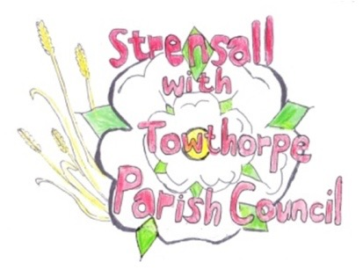
STRENSALL WITH TOWTHORPE PARISH COUNCIL
The Village Hall, Northfields, Strensall, York YO325XW
e-mail: strensalltowthorpePC@outlook.com phone: 01904 491569

MINUTES OF A PLANNING COMMITTEE MEETING HELD ON TUESDAY 10th JANUARY 2023 AT 6.30PM

Councillors Present: Andrew Bolton Christopher Chambers Tony Fisher* Lawrence Mattinson In Attendance: Fiona Hill - Parish Clerk
Public Present: 0
* City of York Councillor

In recognition of the years of service by John Chapman, one minutes silence was observed before the meeting

- a) To receive apologies for absence given in advance of the meeting: Parish Councillors Christopher Tetley
b) To consider the approval of reasons given for absence: Resolved / Approved (Unanimous)

- To receive any declarations of interest under the Parish Council Code of Conduct or
Members register of interests: None

- To approve the minutes of the Planning Committee meeting of 13th December 2022: Resolved / Approved (Unanimous)

22/115 To discuss any ongoing issues and information received:
- 22/002571/CLU – Certificate of Lawfulness for use of land as a farm adventure park @ Piglets Adventure Farm, Towthorpe Grange, Towthorpe Moor Lane (Stockton-on-the-Forest)
The Parish Council noted the content, but agreed to make no action
- Copperfield, Lords Moor Lane – Appeal Decision The Parish Council noted the content
22/116 To consider and respond to consultations from City of York Council to the planning applications as follows: -

a) 22/02476/FUL – Erection of double detached garage @ Hope House, 1A Moor Lane
Resolved / Objections (Unanimous)
The application contravenes the City of York Council Supplementary Planning Documents regarding outbuildings and garages in the front garden, which is detrimental to the street scene and the character, particularly in the Conservation Area.

22/117 To note planning decisions received:

- 22/01298/FUL - Single storey rear and side extension @ 1 Fossview Close – Approved
- 22/01500/TCA - Fell 2no. Sycamore trees; pollard 1no. Lime tree to 2.4m - tree works in a Conservation Area @ The Gables, 2 Church Lane - Consented
- 22/01843/FUL - Erection of outbuilding to front/side elevation @ 34 Kirklands – Refused
- 22/01945/FUL - Erection of oak framed open fronted garage to front elevation @ 521 Strensall Road – Refused
- 22/02358/TCA - Reduce height by 2 metres of 1no. Yew and shape; reduce height by 3 metres of 1no. Holly; remove 2no. stems from 1no. Conifer - tree works in a Conservation Area @ The Grange, 59 The Village - Consented

22/118 To confirm date of next meeting at Tuesday 24th January 2023 @ 6.30 p.m.
Resolved / Approved (Unanimous)

