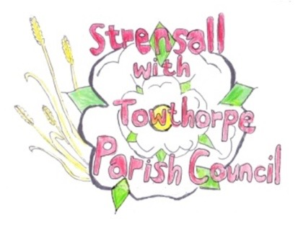
STRENSALL WITH TOWTHORPE PARISH COUNCIL
The Village Hall, Northfields, Strensall, York YO325XW
e-mail: strensalltowthorpePC@outlook.com phone: 01904 491569

MINUTES OF A PLANNING COMMITTEE MEETING HELD ON TUESDAY 13th DECEMBER 2022 AT 6.30PM

Councillors Present: Andrew Bolton Tony Fisher* Lawrence Mattinson Christopher Tetley In Attendance: Fiona Hill - Parish Clerk
Public Present: 0
* City of York Councillor

- a) To receive apologies for absence given in advance of the meeting: Parish Councillors Chambers and Chapman
b) To consider the approval of reasons given for absence: Resolved / Approved (Unanimous)

The Chairman invited and Cllr Tetley accepted to join this committee.

- To receive any declarations of interest under the Parish Council Code of Conduct or
Members register of interests: None

- To approve the minutes of the Planning Committee meeting of 22nd November 2022: Resolved / Approved (Unanimous)

22/108 To discuss any ongoing issues and information received:
22/00116/FUL – 6 The Village – Appeal submitted to Secretary of State
The committee noted this, but was aware that not all documents were uploaded to the CYC Planning Portal on this and other applications.
Resolved / The committee would write to Becky Eades, Head of Planning and Development Services, to ask what documents should be uploaded to comply with the statutory requirements. (Unanimous)
22/109 To consider and respond to consultations from City of York Council to the following planning applications: -
- 22/02210/FUL - Single storey rear extension @ 9 Fossview Close
Resolved / No Objections (Unanimous)

- 22/02235/HR77 - Opinion under Regulation 77 of the Conservation of Habitats and Species Regulations 2017 for the erection of 2m high fence/gates - Strensall Training Area Scott Moncrieff Road
Resolved / No Objections (Unanimous)

- 22/02305/FUL - Conversion of garage to living accommodation @ 4 The Village
Resolved / No Objections, but the development must remain subservient to the main dwelling, for use by the householder only and must not be used as holiday let(Unanimous)

- 22/02368/FUL - Loft conversion with solar panels to rear and 3no. roof lights to front elevation (retrospective) @ 3 Fossview Close
Resolved / No Objections (Unanimous)

22/110 To note planning decisions received:
- 22/01184/FUL – Replacement fence to the rear and sides of war memorial - Approved
- 22/02015/FUL - Single storey rear extension following demolition of existing conservatory @ 7 Duncombe Drive – Approved
- 22/02019/FUL - Single storey rear extension @ 111 The Village - Approved
- 22/02084/FUL - Single storey rear extension following demolition of existing conservatory @ Rowan House, 14 Redmayne Square - Approved
- 22/02095/FUL - Single storey extension @ Montana, 18 York Road - Approved
- 22/02236/TCA - Fell 1no. Ash tree in a Conservation Area @ 130 The Village - Consented

22/111 To confirm date of next meeting at Tuesday 10th January 2023 @ 6.30 p.m.
Resolved / Approved (Unanimous)

