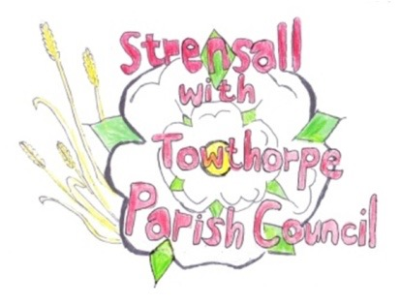
STRENSALL WITH TOWTHORPE PARISH COUNCIL
The Village Hall, Northfields, Strensall, York YO325XW
e-mail: strensalltowthorpePC@outlook.com phone: 01904 491569

MINUTES OF A PLANNING COMMITTEE MEETING HELD ON TUESDAY 14th FEBRUARY 2023 AT 6.30PM
Councillors Present: Andrew Bolton Christopher Chambers Tony Fisher* Lawrence Mattinson Christopher Tetley In Attendance: Fiona Hill - Parish Clerk
Public Present: 2
* City of York Councillor
- a) To receive apologies for absence given in advance of the meeting: None
b) To consider the approval of reasons given for absence: N/A

- To receive any declarations of interest under the Parish Council Code of Conduct or
Members register of interests: None

- To approve the minutes of the Planning Committee meeting of 10th January 2023:
(The meeting on 24th January 2023 was cancelled) Resolved / Approved (Unanimous)

22/115 To discuss any ongoing issues and information received: None
22/116 To consider and respond to consultations from City of York Council to the planning applications as follows: -

- 23/00073/FUL - Erection of 1no. two storey four bedroom dwelling following demolition of existing 3 bedroom bungalow and detached garage @ Copperfield, Lords Moor Lane
Resolved / No Objection (Unanimous)
- 23/00127/TCA – Fell 1no. Sycamore tree in a Conservation Area @ 1A Northfields
Resolved / Objection (Unanimous)
There is a lack of detail within the application, in which no valid reason is given for felling the tree, where crown reduction may be more appropriate.
- 23/00188/ABC3 - Change of use of agricultural building to 1no. dwellinghouse under Class Q Part 3 Schedule 2 of Article 3 of The Town and Country Planning (General Permitted Development) Order 2015 @ Cow Slip Farm Lords Moor Lane
Resolved / No Objection (Unanimous)

22/117 To note planning decisions received:
- 22/02207/FUL - Dormer to rear @ 106 The Village - Approved
- 22/02210/FUL - Single storey rear extension @ 9 Fossview Close – Approved
- 22/02305/FUL - Conversion of garage to living accommodation @ 4 The Village – Approved
- 22/02368/FUL - Loft conversion with solar panels to rear and 3no. roof lights to front elevation (retrospective) @ 3 Fossview Close - Approved

22/118 To confirm date of next meeting at Tuesday 28th February 2023 @ 6.30 p.m.
Resolved / Approved (Unanimous)

