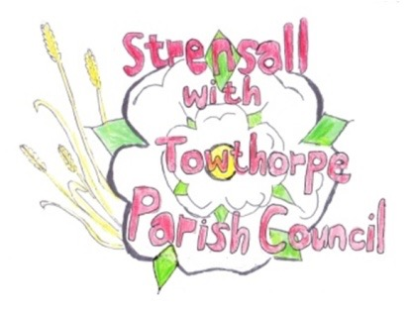
STRENSALL WITH TOWTHORPE PARISH COUNCIL
The Village Hall, Northfields, Strensall, York YO325XW
e-mail: strensalltowthorpePC@outlook.com phone: 01904 491569

MINUTES OF A PLANNING COMMITTEE MEETING HELD ON TUESDAY 28th FEBRUARY 2023 AT 6.30PM

Councillors Present: Andrew Bolton Christopher Chambers Lawrence Mattinson In Attendance: Fiona Hill - Parish Clerk
Public Present: 0

- a) To receive apologies for absence given in advance of the meeting: Christopher Tetley
b) To consider the approval of reasons given for absence: Resolved / Approved (Unanimous)

- To receive any declarations of interest under the Parish Council Code of Conduct or
Members register of interests: None

- To approve the minutes of the Planning Committee meeting of 14th February 2023:
Resolved / Approved (Unanimous)

22/122 To discuss any ongoing issues and information received: a) 22/01669/FUL – The Sycamores, 12 The Village – Revised Drawings
The application has now been approved, but the flat roof had been conditioned that it cannot be used as a balcony.
b) 22/00775/FUL – 37 York Road – Appeal
This application has now been approved, but the applicant had appealed against the condition that the shed should be a brown colour,
22/123To consider and respond to consultations from City of York Council to the planning applications as follows: -

- 23/00290/TCA – Fell 1 no. Field Maple tree in a Conservation Area @ 12 West End
Resolved / No Objection (Unanimous), subject to the approval of the City of York Council Tree Officer.

22/124 To note planning decisions received: None

22/125 To confirm date of next meeting at Tuesday 13th March 2023 @ 6.30 p.m.
Resolved / Approved (Unanimous)

