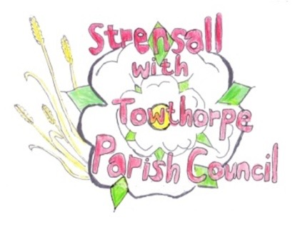
STRENSALL WITH TOWTHORPE PARISH COUNCIL

The Village Hall, Northfields, Strensall, York YO325XW
e-mail: strensalltowthorpePC@outlook.com
phone: 01904 491569
Chairman : Mr A H Fisher

MINUTES OF AN PARISH COUNCIL MEETING HELD IN THE VILLAGE HALL ON TUESDAY 11th April 2023 AT 7.15 PM

Councillors Present: Andrew Bolton Chris Chambers Tony Fisher* Lawrence Mattinson Susan Nunn Wayne Wigley
Christopher Tetley

In Attendance: Cllr Paul Doughty* Carrie Pillow – Locum Parish Clerk
Public Present: 1
* City of York Councillor

- a) To receive apologies for absence given in advance of the meeting:

None, but no access to emails, during Parish Clerk absence, to be reviewed at next meeting

b) To consider the approval of reasons given for absence: N/A

- To discuss the ordinary and casual vacancies: NTR

- a) To approve the minutes of the Parish Council meeting of 14th March 2023:
Resolved / Approved (Unanimous)
b) To endorse the approved Planning Committee minutes of 14th and 28th March 2023:
Resolved / Endorsed (Unanimous)

- Public participation on any:

Manor Park, Sheriff Hutton Road – MOP reported Accident, asked if anything could be done re speeding; chair confirmed this is a highways issue; The PC has no power to act, but would forward any letters from the public to highways.

22/105 To receive matters raised by/with City of York Ward Councilors:
- CYC Ward Cllr Paul Doughty stated that in the pre-election period there was nothing new to report from the last meeting.
- Cllrs were hopeful that the Neighbourhood Plan would be approved by CYC Executive to proceed to referendum on Thursday 04th May 2023 and asked the Ward Cllrs to support it.

22/106 To discuss and, if necessary, agree action on matters arising/ongoing issues:
a) North Yorkshire Police monthly reports – None
b) Queen Elizabeth II Memorial Garden – The Parish Council is awaiting permission from City of York Council regarding services.
The locum clerk advised the Council to add the lifespan of any trees to plan and state in minutes possible need to remove and replace.

22/107 To confirm the date of the next meeting as Tuesday 9th May 2023 at 7.15 p.m.:
Resolved / Approved (Unanimous)
Important Dates: Annual Parish Council Meeting Tuesday 09th May 2023 @ 7.15p.m.
Annual Parish Meeting Tuesday 23rd May 2023 @ 7.15p.m.

