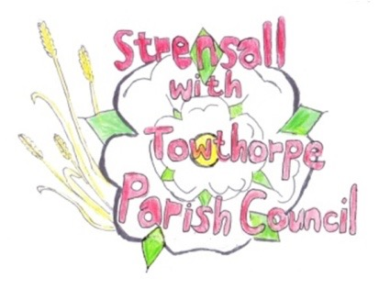
STRENSALL WITH TOWTHORPE PARISH COUNCIL
The Village Hall, Northfields, Strensall, York YO325XW
e-mail: strensalltowthorpePC@outlook.com phone: 01904 491569

MINUTES OF A PLANNING COMMITTEE MEETING HELD ON TUESDAY 14th MARCH 2023 AT 6.30PM

Councillors Present: Andrew Bolton Christopher Chambers Tony Fisher Lawrence Mattinson Christopher Tetley In Attendance: Fiona Hill - Parish Clerk
Public Present: 0

- a) To receive apologies for absence given in advance of the meeting: None b) To consider the approval of reasons given for absence: N/A

- To receive any declarations of interest under the Parish Council Code of Conduct or
Members register of interests:
Cllr Bolton – 23/00344/FUL – who left the meeting room whilst this item was discussed and Cllr Chambers took over as Chairman for this item.

- To approve the minutes of the Planning Committee meeting of 28th February 2023: Resolved / Approved (Unanimous)

22/129 To discuss any ongoing issues and information received: a) Hawthornes – CYC Planning Enforcement had advised that the driveway did not breach the planning approval, but CYC Highways had been asked to inspect the site.
22/130 To consider and respond to consultations from City of York Council to the planning applications as follows: -

- 23/00344/FUL – Erection of solid brise soleil to rear and installation of Juliet balcony to rear doors (retrospective) @ Greensleeves, Lords Moor Lane
Resolved / Objection (Unanimous), the slatted brise soleil offers protection against the possibility of a sitting out area, so it should not be changed to a solid brise soleil.

- 23/00405/FUL – Single storey rear extension after removal of conservatory @ 6 Renfrew Green
Resolved / No Objection (Unanimous)

22/131 To note planning decisions received:
- 22/01669/FUL - Erection of detached dwelling to side/west of 12 The Village @ The Sycamores, 12 The Village – Approved
- 22/02476/FUL - Erection of double detached garage @ Hope House 1A Moor Lane – Approved
- 23/00127/TCA - Fell 1no. Sycamore tree in a Conservation Area @ 1A Northfields – Consented*

*The Parish Council had contacted the CYC Planning Officer to ask – “The Parish Council was surprised that this work was given consent, when no reason was given in the application for felling. To assist the Parish Council, please can you advise them the reasons for your decision”.
The CYC Planning Officer had responded as follows – “When we looked into it, it transpired that the tree neither had a TPO on it, nor was it quite within the conservation area, so the local authority had no jurisdiction to ‘refuse’ its removal. This is also the reason why the letter was sent out early. I hope that clarifies matters. Apologies if we did not explain this directly to yourselves at the time”.
The Parish Council noted this guidance for the future.
22/132 To confirm date of next meeting at Tuesday 28th March 2023 @ 6.30 p.m.
Resolved / Approved (Unanimous)

