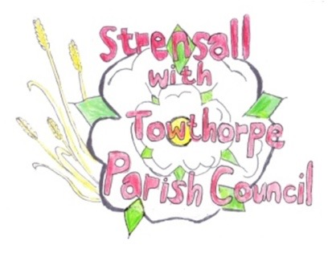
STRENSALL WITH TOWTHORPE PARISH COUNCIL
The Village Hall, Northfields, Strensall, York YO325XW
e-mail: strensalltowthorpePC@outlook.com phone: 01904 491569

MINUTES OF A PLANNING COMMITTEE MEETING HELD ON TUESDAY 25th APRIL 2023 AT 6.30PM

Councillors Present: Andrew Bolton Christopher Chambers Tony Fisher Christopher Tetley In Attendance: Fiona Hill - Parish Clerk
Public Present: 0

- a) To receive apologies for absence given in advance of the meeting: Parish Councillor Lawrence Mattinson b) To consider the approval of reasons given for absence: Resolved / Approved (Unanimous)

- To receive any declarations of interest under the Parish Council Code of Conduct or
Members register of interests: None

- To approve the minutes of the Planning Committee meeting of 11th April 2023: Resolved / Approved (Unanimous)

- To discuss any ongoing issues and information received: None

- To consider and respond to consultations from City of York Council to the planning applications as follows: 23/00467/FUL - Two storey side extension after removal of garage @ 19 Middlecroft Drive

- To note planning decisions received:

- To confirm date of next meeting at Tuesday 11th March 2023 @ 6.30 p.m.
Resolved / Approved (Unanimous) -

