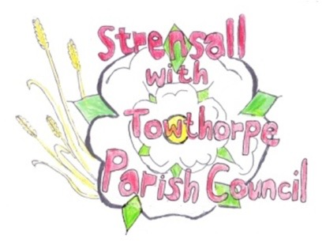
STRENSALL WITH TOWTHORPE PARISH COUNCIL
The Village Hall, Northfields, Strensall, York YO325XW
e-mail: strensalltowthorpePC@outlook.com phone: 01904 491569

MINUTES OF A PLANNING COMMITTEE MEETING HELD ON TUESDAY 23rd MAY 2023 AT 6.30PM
Councillors Present: Andrew Bolton Christopher Chambers Tony Fisher Lawrence Mattinson In Attendance: Fiona Hill - Parish Clerk
Public Present: 0
- a) To receive apologies for absence given in advance of the meeting: Parish Councillors Christopher Tetley and Wayne Wigley b) To consider the approval of reasons given for absence: Resolved / Approved (Unanimous)

- To receive any declarations of interest under the Parish Council Code of Conduct or
Members register of interests: 23/00913/FUL – Cllr Fisher is a good friend of the applicants neighbour.

- To approve the minutes of the Planning Committee meeting of 25th April 2023: (The meeting on 09 May 2023 was cancelled) Resolved / Approved (Unanimous)

- To discuss any ongoing issues and information received: None

- To consider and respond to consultations from City of York Council to the planning applications as follows: a) 23/00913/FUL – Single storey rear extension after removal of conservatory - retrospective @ 15 Westpit Lane
Resolved / No Objection (Unanimous)
b) 23/00934/TCA – Fell 1no. mature Beech – tree in Conservation Area @ 69 The Village
Resolved / Objection (Unanimous)
There is no justification for felling this mature tree in the Conservation Area. Sympathetic crown reduction, with guidance from the City of York Council Tree Officer, should be the only action taken.

- To note planning decisions received: a) 23/00467/FUL – Two storey side extension after removal of garage @ 19 Middlecroft Drive - Approved

- To confirm date of the next meeting on Tuesday 13th June 2023 @ 6.30 p.m.
Resolved / Approved (Unanimous)

