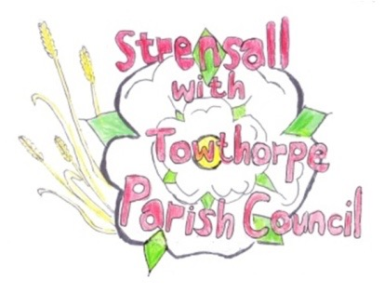
STRENSALL WITH TOWTHORPE PARISH COUNCIL
The Village Hall, Northfields, Strensall, York YO325XW
e-mail: strensalltowthorpePC@outlook.com phone: 01904 491569

MINUTES OF A PLANNING COMMITTEE MEETING HELD ON TUESDAY 13th JUNE 2023 AT 6.30PM
Councillors Present: Andrew Bolton Christopher Chambers* Tony Fisher Lawrence Mattinson Wayne Wigley
In Attendance: Fiona Hill - Parish Clerk
Public Present: 0
*Arrived late
- a) To receive apologies for absence given in advance of the meeting: Parish Councillors Christopher Tetley b) To consider the approval of reasons given for absence: Resolved / Approved (Unanimous)

- To receive any declarations of interest under the Parish Council Code of Conduct or
Members register of interests: None

- To approve the minutes of the Planning Committee meeting of 23th May 2023: Resolved / Approved (Unanimous)

- To discuss any ongoing issues and information received: None

- To consider and respond to consultations from City of York Council to the planning applications as follows: a) 23/01030/FUL – Dormer @ 7 Netherwoods
Resolved / No Objection (Unanimous)
b) 23/01127/TPO – Reduce lowest limbs on North Western side of T1 Oak tree protected by TPO 1982/49 – T1 by up to 2m @ Oak Tree Cottage, Ox Carr Lane
Resolved / No Objection (Unanimous)
Subject to approval from the City of York Council Tree Officer.

- To note planning decisions received: None

- To confirm date of the next meeting on Tuesday 27th June 2023 @ 6.30 p.m.
Resolved / Approved (Unanimous)

