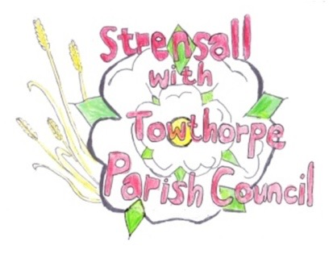
STRENSALL WITH TOWTHORPE PARISH COUNCIL
The Village Hall, Northfields, Strensall, York YO325XW
e-mail: strensalltowthorpePC@outlook.com phone: 01904 491569

MINUTES OF A PLANNING COMMITTEE MEETING
HELD ON TUESDAY 27th JUNE 2023 AT 6.30PM

Councillors Present: Andrew Bolton Christopher Chambers Tony Fisher Christopher Tetley
In Attendance: Fiona Hill - Parish Clerk
Public Present: 0
- a) To receive apologies for absence given in advance of the meeting: Parish Councillors Lawrence Mattinson and Wayne Wigley b) To consider the approval of reasons given for absence: Resolved / Approved (Unanimous)

- To receive any declarations of interest under the Parish Council Code of Conduct or
Members register of interests: Cllr Fisher reported that he had been involved in the enforcement cases at 32 Westpit Lane, but the Chairman was satisfied this is a separate issue, so he would remain in the meeting, whilst this application was discussed.

- To approve the minutes of the Planning Committee meeting of 13th June 2023: Resolved / Approved (Unanimous)

- To discuss any ongoing issues and information received: None

- To consider and respond to consultations from City of York Council to the planning applications as follows: a) 23/00995/FUL – Retention of extension to shed and 2no. stock shelters @ Country Park,
Pottery Lane
Resolved / No Objection (Unanimous), it must not be ancillary to the caravan park and should only be used for agricultural purposes.
b) 23/01163/FUL – Balcony to rear (retrospective) @ 32 Westpit Lane
Resolved / Strongly Object (Unanimous), for the reasons as follows:
- The retention of this unauthorised balcony contravenes condition four of planning approval 19/01365/FUL dated 18 September 2019
- In addition, the unauthorised balcony would cause harm to the privacy and amenity of neighbouring properties.
- The development fails to accord with the amenity protection aims set out in paragraphs 3.1 and 3.4 of the City of York House Extensions and Alterations Draft Supplementary Planning Document.

- To note planning decisions received: None

- To confirm date of the next meeting on Tuesday 11th July 2023 @ 6.30 p.m.
Resolved / Approved (Unanimous)

