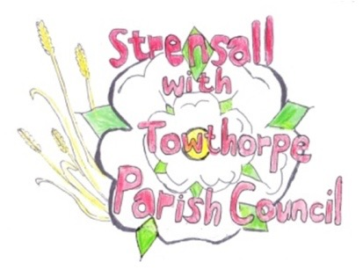
STRENSALL WITH TOWTHORPE PARISH COUNCIL
The Village Hall, Northfields, Strensall, York YO325XW
e-mail: strensalltowthorpePC@outlook.com phone: 01904 491569

MINUTES OF A PLANNING COMMITTEE MEETING
HELD ON TUESDAY 22nd AUGUST 2023 AT 6.30PM

Councillors Present: Andrew Bolton Christopher Chambers Tony Fisher Christopher Tetley
In Attendance: Fiona Hill - Parish Clerk
Public Present: 1

- a) To receive apologies for absence given in advance of the meeting: None b) To consider the approval of reasons given for absence: N/A

- To receive any declarations of interest under the Parish Council Code of Conduct or
Members register of interests: None

- To approve the minutes of the Planning Committee meeting of 08th August 2023: Resolved / Approved (Unanimous)

- To discuss any ongoing issues and information received: None

- To consider and respond to consultations from City of York Council to the planning applications as follows: a) 23/01188/FUL – Removal of condition 5 of permitted application 08/02144/FUL to alter
materials of doors and windows to a powder coating grey finish @ 1 Princess Road
Resolved / No Objection, subject to windows passing modern thermal standards. (Unanimous)

- To note planning decisions received: None

- To confirm date of the next meeting on Tuesday 12th September2023 @ 6.30 p.m.
Resolved / Approved (Unanimous)

