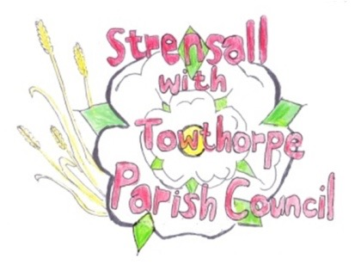
STRENSALL WITH TOWTHORPE PARISH COUNCIL
The Village Hall, Northfields, Strensall, York YO325XW
e-mail: strensalltowthorpePC@outlook.com phone: 01904 491569

MINUTES OF A PLANNING COMMITTEE MEETING
HELD ON TUESDAY 10th OCTOBER 2023 AT 6.30PM

Councillors Present: Andrew Bolton Christopher Chambers Tony Fisher Lawrence Mattinson Chris Tetley
In Attendance: Fiona Hill - Parish Clerk
Public Present: 0

- a) To receive apologies for absence given in advance of the meeting: None b) To consider the approval of reasons given for absence: N/A

- To receive any declarations of interest under the Parish Council Code of Conduct or
Members register of interests: None

- To approve the minutes of the Planning Committee meeting of 26th September 2023:
(The meeting on 12th September 2023 was cancelled) Resolved / Approved (Unanimous)

- To discuss any ongoing issues and information received: None

- To consider and respond to consultations from City of York Council to the planning applications as follows: a) 23/01833/TPO - Crown lifting to 6m and removal of epicormic growth on 3 no. Oak trees
protected by Tree Preservation Order Tree 169/1991 @ 73 Northfields
Resolved – No Objection, subject to guidance from the City of York Council Tree Officer, as the Parish Council is concerned that crown lifting to 6m is too high. The Parish Council would prefer to see minimal work done to clear the house. The accompanying map shows the trees in the neighbouring property.

- To note planning decisions received:
- 23/01108/CPD - Certificate of lawfulness for proposed development of a ground mounted solar panels, temporary construction compound and perimeter fencing (up to 2.7m high) @ Walbutts Sewage Works, Brecks Lane - Consented
- 23/01163/FUL - Balcony to rear (retrospective) @ 32 Westpit Lane – Refused
- 23/01413/FUL - Single storey side extension for a conservatory following demolition of existing conservatory @ 1 Low Croft - Approved

- To confirm date of the next meeting on Tuesday 24th October 2023 @ 6.30 p.m.
Resolved / Approved (Unanimous)

