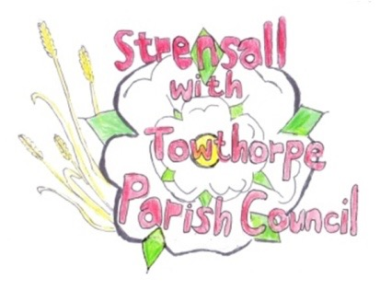
STRENSALL WITH TOWTHORPE PARISH COUNCIL
The Village Hall, Northfields, Strensall, York YO325XW
e-mail: strensalltowthorpePC@outlook.com phone: 01904 491569

MINUTES OF A PLANNING COMMITTEE MEETING
HELD ON TUESDAY 24th OCTOBER 2023 AT 6.30PM

Councillors Present: Andrew Bolton Christopher Chambers Tony Fisher Chris Tetley
In Attendance: Fiona Hill - Parish Clerk
Public Present: 0
- a) To receive apologies for absence given in advance of the meeting: None b) To consider the approval of reasons given for absence: N/A

- To receive any declarations of interest under the Parish Council Code of Conduct or
Members register of interests: None

- To approve the minutes of the Planning Committee meeting of 10th October 2023:
Resolved / Approved (Unanimous)

- To discuss any ongoing issues and information received: None

- To consider and respond to consultations from City of York Council to the planning applications as follows: a) 23/01843/FUL - Variation of condition 2 of permitted application 19/02463/FULM to alter the routing of the permanent maintenance access track and design of the outfall from
permanent Borrow Pit P2 @ Foss Upstream Storage Area Brecks Lane Resolved / No Objection (Unanimous) b) 23/01798/FUL - Restoration of 1no. wildlife pond and associated soil spreading @ Strensall Common SSSI, Lords Moor Lane
Resolved / No Objection (Unanimous)

- To note planning decisions received:
a) 22/01032/FUL - Change of use of agricultural land to the siting of 118 storage containers (use class B8) – retrospective @ BHE Self Storage Self Storage Facility, Lambshill, Towthorpe Moor Lane - Refused
b) 23/00995/FUL - Retention of extension to shed and 2 no. stock shelters (for agricultural use) @ Country Park, Pottery Lane - Approved
c) 23/01687/FUL - Single storey rear extension following removal of conservatory (retrospective) @ 9 Westpit Lane – Approved
- To confirm date of the next meeting on Tuesday 14th November 2023 @ 6.30 p.m.
Resolved / Approved (Unanimous)

