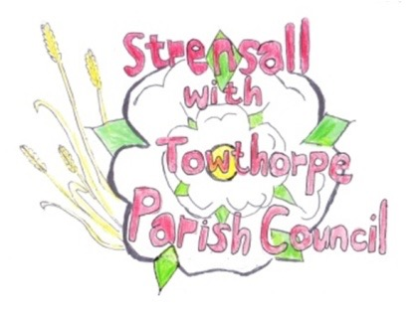**STRENSALL WITH TOWTHORPE PARISH COUNCIL**

The Village Hall, Northfields, Strensall, York YO325XW

e-mail: [strensalltowthorpePC@outlook.com](mailto:strensalltowthorpePC@outlook.com)

phone: 01904 491569

Chairman : Mr A H Fisher

**MINUTES OF AN PARISH COUNCIL MEETING HELD IN THE VILLAGE HALL ON TUESDAY 14th NOVEMBER 2023 AT 7.15 PM**

**Councillors Present:** Andrew Bolton Tony Fisher1 Lawrence Mattinson Susan Nunn Daniel Pillai Chris Tetley

**In Attendance:** Fiona Hill – Parish Clerk

**Public Present:** 0

1 City of York Councillor

1. **a) To receive apologies for absence given in advance of the meeting:**

Chris Chambers **b) To consider the approval of reasons given for absence:** N/AResolved / Approved (Unanimous)

1. **To discuss the ordinary and casual vacancies:** NTR
2. **To receive any declarations of interest under the Parish Council Code of Conduct or**

**Members register of interests:** Cllr Bolton – Fallen tree on Lords Moor Lane

1. **a) To approve the minutes of the Parish Council meeting of 10th September 2023:**

Resolved / Approved (Unanimous)

**b) To endorse the approved Planning Committee minutes of 10th and 24th October 2023:**

Resolved / Endorsed (Unanimous)

1. **Public participation on any subject relating to the agenda:** None

**24/68 To receive matters raised by/with City of York Ward Councillors:**  Cllr Fisher reported as follows - - The resurfacing on the Common Road had been completed. - The 30MPH at Towthorpe is imminent.

**24/69 To discuss and, if necessary, agree action on matters arising/ongoing issues:** a)North Yorkshire Police monthly reports The Parish Council noted receipt of the monthly report. c) Queen Elizabeth II Memorial Garden Ground Solution Services had provided examples of similar work and their insurance details but had yet to provide clarification of the 15M and the acceptance of working hours. The Parish Council would give them fourteen days to provide this information and if not received the contract would be rescinded. d) Road Closure Request – Remembrance Day The event was a great success and the road closure had certainly been most helpful in improving the safety of the event. Community TM Ltd would be asked to lead arrangements for 2024.

**24/70 To discuss and, if necessary, agree action on matters raised since last meeting:** a) Strensall Events Committee – Carnival – Grant Application

Resolved – The Parish Council awarded a grant of up to £2000.00, towards the road closure and first aid arrangements. Invoices would be sent to the Parish Council, to be paid directly (Unanimous)

**24/71 To discuss and, if necessary, agree action, on any correspondence received:** None

**24/72 To discuss matters raised by/with Parish Clerk/Responsible Financial Officer (RFO):** a)Bank reconciliation, income received, payments made to date:

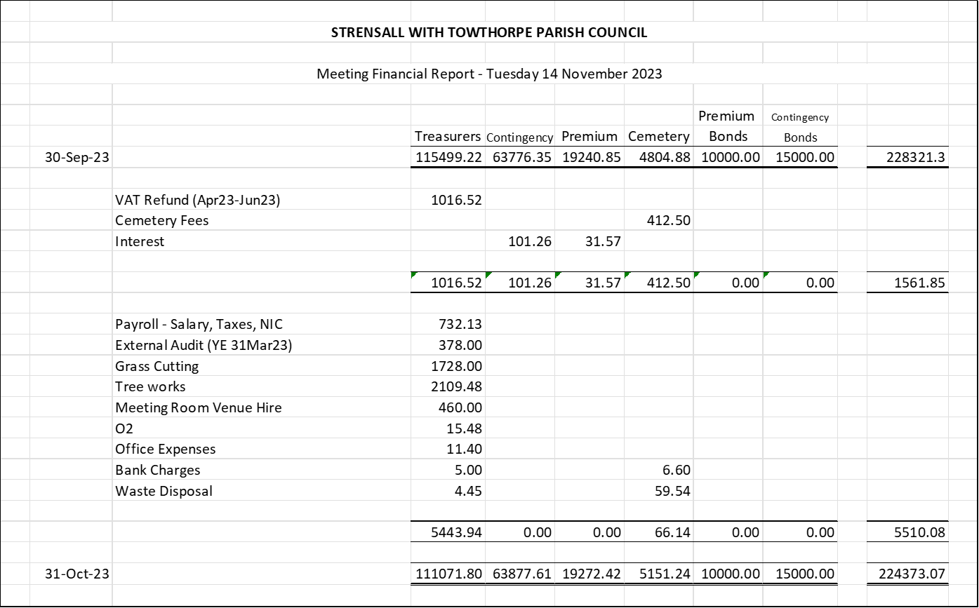

b)Budget 2024/2025

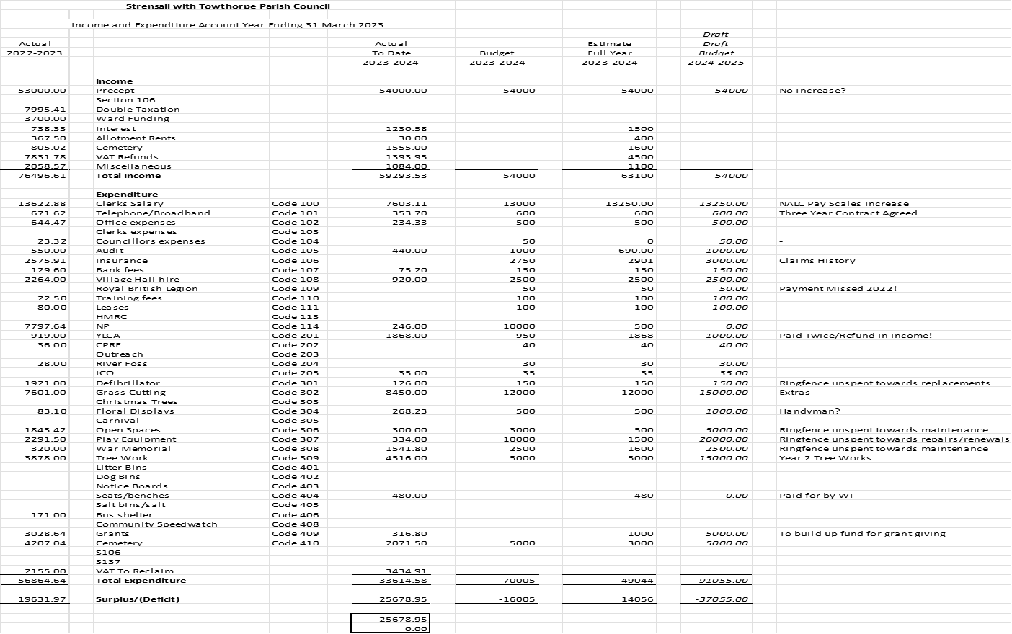

Ring-fenced/Earmarked Funds:

As at 31 October 2023: In addition to budget above:

Cowslip Bridge 14000.00

Return to General Reserve + 14000

Tree works 10484.00

Transfer £10000 from General Reserve towards urgent tree work - 10000

Grants 3392.00 -

Play Areas 14666.00

Transfer £50000 from General Reserve towards Play Area Renewals - 50000

General Reserve 181801.00 135801

A General Reserve of £135801 is closer to the recommended “twice the value of the precept”

c) Internal Controls Checks: The had been conducted as part of the interim audit.

d) Yorkshire Local Councils Association: Information provided was circulated around Cllrs.

e) Policy Review –

Employment/Personnel:

The Parish Council has all of the statutory required policies:

* Contract of Employment
* Expenses Policy
* Health & Safety Policy

The Parish Council has most of the best practice policies:

* Employing people procedures – YLCA guidance/templates used
* Job Descriptions – YLCA guidance/templates used
* Grievance procedures
* Disciplinary procedures
* Dignity at Work
* Equality & Diversity/Equal Opportunities Policy
* Payroll records, notice of tax code and holiday record
* Sickness absence policy and records
* Business Continuity Plan
* Accident Book
* Training Statement of Intent and training records
* Auto-enrolment Policy working policy
* Lone working policy
* Annual appraisal record

The Parish Clerk will research the following:

* Working from home policy
* Working Time Policy
* Computer use, electronic communications and email use policy
* Pension & Retirement Policy
* Flexible working policy
* Disabled Access policy
* Member/Officer Protocol
* Use of own vehicles for work

A summary of the Policy Review would be done ready for the December 2023 meeting.

e) Payments Approval –



f) Monthly Report from Parish Office

Wild Flowers – Leyfield Close has been postponed due to the size of the project, the need for specialist advice and the failure to obtain an accurate quote. However, a resident has volunteered to trial a wildflower project on the grassed area adjacent to the Play Area at Kirklands. Cllr Fisher gave further details at the meeting and Cllrs were happy for this project to go ahead.

Tree Report 2023 – Year One works were completed this year. Quotes to be obtained for Year Two works, which are due to be done during 2024.

Fallen Tree/Lords Moor Lane – The tree is in the hedge and has fallen across the ditch onto Parish Council land. Looking at the land lease, it appears the boundary is along the hedge and the ditch is on the Parish Council side. Therefore, the hedge, along with the tree, belongs to the owners of the field. The landowner would be asked to arrange for the tree to be removed.

Play Areas – The specification for post ROSPA works is drafted on about to be submitted to contractors to obtain quotations.

Insurance - Gallagher & Co have arranged the renewal with Hiscock, which has been accepted.

Cemetery Matters:

*Topple Testing* – The Parish Council was aware of the unfortunate saga involving Haxby Town Council. With The Parish Clerk thought it would be a good idea to ensure there were policies/procedures in place. Cllr Fisher and the Parish Clerk visited the cemetery and judged the risk to be low, as all headstones are relatively modern and low lying. The Parish Clerk will report to the next meeting, when the necessary guidance is obtained.

*Exclusive Right of Burial* – A couple who have purchased neighbouring plots, have now moved away and no longer wish to be buried in Strensall Cemetery. The Parish Council agreed that if the original grants are returned, the fees can be returned in full.

*Interment Attendance* – It is not a statutory requirement for a burial clerk to attend interments and on speaking to funeral directors, they confirm that it is their responsibility to ensure the correct person in buried in the correct place. Afterall, even when the Burial Clerk observes, they are not achieving anything and have sometimes waited over an hour, when funeral running late, which is not good value for money. Obviously, the Burial Clerk marks the grave and returns to ensure tidy work. This will be regularly reviewed and should there ever be multiple interments, the Burial Clerk will attend to avoid mix ups!

**24/73 To confirm the date of the next meeting as Tuesday 12th December 2023 at 7.15 p.m.:** Resolved / Approved (Unanimous)