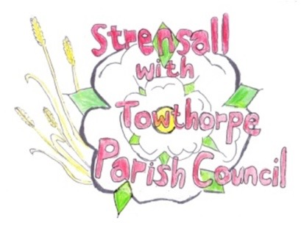
STRENSALL WITH TOWTHORPE PARISH COUNCIL
The Village Hall, Northfields, Strensall, York YO325XW
e-mail: strensalltowthorpePC@outlook.com phone: 01904 491569

MINUTES OF A PLANNING COMMITTEE MEETING
HELD ON TUESDAY 12th DECEMBER 2023 AT 6.30PM

Councillors Present: Andrew Bolton Tony Fisher Lawrence Mattison
In Attendance: Fiona Hill - Parish Clerk
Public Present: 0
- a) To receive apologies for absence given in advance of the meeting: Parish Councillors Chris Chambers and Chris Tetley b) To consider the approval of reasons given for absence: Resolved / Approved (Unanimous)

- To receive any declarations of interest under the Parish Council Code of Conduct or
Members register of interests: None

- To approve the minutes of the Planning Committee meeting of 28th Novemberber 2023:
Resolved / Approved (Unanimous)

- To discuss any ongoing issues and information received: None

- To consider and respond to consultations from City of York Council to the planning a applications as follows:

- 23/02117/FUL – Change of use of agricultural land to the siting of 104 storage containers (use class B8) – retrospective (resubmission) @ BHE Self Storage Self Storage Facility, Lambshill, Towthorpe, Moor Lane
Resolved / Objection, as there are no significant changes to the previous application. The development is harmful to the greenbelt and there are no very special circumstances. The Parish Council fully supports City of York Councils decision 22/01032/FUL (Unanimous)

- 23/02185/TCA – Fell 1 no. Sycamore located in garden of 6 The Village – tree in a conservation area @ 6 The Village
Resolved / No Objection, subject to the development going ahead at No. 12 The Village and the proposed new trees being planted. (Unanimous)

- To note planning decisions received: None

- To confirm date of the next meeting on Tuesday 10th January 2024 @ 6.30 p.m.
Resolved / Approved (Unanimous)

