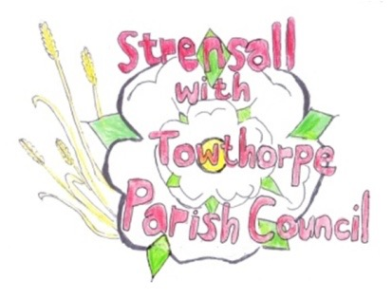
STRENSALL WITH TOWTHORPE PARISH COUNCIL
The Village Hall, Northfields, Strensall, York YO325XW
e-mail: strensalltowthorpePC@outlook.com phone: 01904 491569

MINUTES OF A PLANNING COMMITTEE MEETING
HELD ON TUESDAY 14th NOVEMBER 2023 AT 6.30PM

Councillors Present: Andrew Bolton Tony Fisher Lawrence Mattison Chris Tetley
In Attendance: Fiona Hill - Parish Clerk
Public Present: 0
- a) To receive apologies for absence given in advance of the meeting: Christopher Chambers b) To consider the approval of reasons given for absence: Resolved / Approved (Unanimous)

- To receive any declarations of interest under the Parish Council Code of Conduct or
Members register of interests: None

- To approve the minutes of the Planning Committee meeting of 24th October 2023:
Resolved / Approved (Unanimous)

- To discuss any ongoing issues and information received: None
23/47 To consider and respond to consultations from City of York Council to the planning applications as follows:
- 23/01079/FUL - Erection of shed – retrospective @ Land To The Rear Of 34 Westpit Lane
Resolved / No Objection (Unanimous), in principle, subject to the shed being identified for sole use of the applicant for storage only of machinery relating to the maintenance of the land, with no electricity or services to the shed. Ideally, the shed should be relocated adjacent the boundary, to the domestic curtilage. If approval is granted it should be to the applicant only and not future occupants.

- 23/01812/FUL - Dropped kerb crossing and driveway to front @ The Sycamores 12 The Village
Resolved / No Objection (Unanimous)

- 23/01929/TCA - Reduce back branches by 1m over conservatory of 1 no. Oak situated on Parish Council land adjacent to 103 The Village - tree in a Conservation Area @ 65 Northfields
Resolved / No Objection (Unanimous), subject to the work being done by a professional tree surgeon under the supervision of a City of York Council tree officer.

- 23/01970/TPO - Up to 15% lateral reduction of Oak to give clearance from property - tree protected by Tree Preservation Order 131/1989 @ 2 Oak Tree Close
Resolved / No Objection (Unanimous), subject to the work being done by a professional tree surgeon under the direct supervision of a City of York Council tree officer. Pruning of the tree should maintain the overall balance of the tree, not affecting the health of the tree and the 15% lateral reduction should be the absolute maximum.

23/48 To note planning decisions received: None

- To confirm date of the next meeting on Tuesday 28th November 2023 @ 6.30 p.m.
Resolved / Approved (Unanimous)

