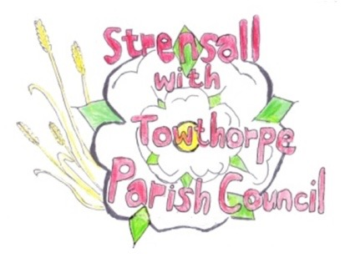
STRENSALL WITH TOWTHORPE PARISH COUNCIL
The Village Hall, Northfields, Strensall, York YO325XW
e-mail: strensalltowthorpePC@outlook.com phone: 01904 491569

MINUTES OF A PLANNING COMMITTEE MEETING
HELD ON TUESDAY 28th NOVEMBER 2023 AT 6.30PM

Councillors Present: Andrew Bolton Christopher Chambers Tony Fisher Lawrence Mattison
In Attendance: Fiona Hill - Parish Clerk
Public Present: 0
- a) To receive apologies for absence given in advance of the meeting: None b) To consider the approval of reasons given for absence: N/A

- To receive any declarations of interest under the Parish Council Code of Conduct or
Members register of interests: None

- To approve the minutes of the Planning Committee meeting of 14th Novemberber 2023:
Resolved / Approved (Unanimous)

- To discuss any ongoing issues and information received: None

- To consider and respond to consultations from City of York Council to the planning a applications as follows:

- 23/02069/FUL – Single storey side and rear extensions following demolition of rear projection and attached garage @ 27 York Road
Resolved / No Objection (Unanimous)

- 23/02141/FUL – Part single part two storey rear extension and dormer to rear following demolition of existing conservatory @ 8 Oak tree Way
Resolved / No Objection, to the overall scheme, but believe the rear dormer should be set down further from the apex of the roof, in line with supplementary design guidance (Unanimous)

- To note planning decisions received: None

- To confirm date of the next meeting on Tuesday 12th December 2023 @ 6.30 p.m.
Resolved / Approved (Unanimous)

