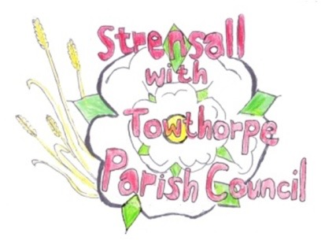
STRENSALL WITH TOWTHORPE PARISH COUNCIL
CO-OPTION POLICY

This policy outlines the procedure to be followed by Strensall with Towthorpe Parish Council when a casual vacancy arises by virtue of councillor resignation, disqualification or death.
Electoral services at the Principal Authority to be informed of the vacancy; 14 days-notice to electors to call a poll must be provided. Assuming there is no call for a bye-election the council with fill the vacancy by co-option using the following procedure:
1. A notice is erected in a conspicuous place in the parish inviting people who are interested in being a parish councillor to write to the council/complete an application.

2. The notice advertising the vacancy will contain a closing date for receipt of applications.

3. Upon receipt, the council must check (as far as reasonably possible, using the YLCA eligibility checklist) that candidates are eligible in accordance with the Local Government Act 1972, section 79.
In order to be eligible, the candidate must:
- be 18 years old or over; and
- is an elector for the parish; or
- has resided in the parish for the past twelve months or rented/tenanted land in the parish; or
- had his/her principal place of work in the parish; or
- has lived within three miles (direct) of the parish.
and not disqualified from being a councillor by virtue of section 80 of the Local Government Act 1972.

4. Following receipt of applications, the next suitable council meeting will have an agenda item 'To receive written applications for the office of parish councillor and to co-opt a candidate to fill the existing vacancy'.

NOTE: The council can choose how to manage this part of the process and may make its selection using information in the written application only or it may invite the candidates to come to the meeting to say a bit about themselves, which is actually quite a useful exercise.
Is important to remember that It the process must be transparent, fair and equitable.
How the council resolves to manage this process should be detailed here; for example:

5. The council will consider all applications at a meeting of the council and resolve to co-opt the most suitable candidate.

or

5. The council will request all those submitting an application to attend a parish council meeting and provide a short (specify the time) presentation as to their suitability as a parish councillor, prior to resolving to co-opt the most suitable candidate.

or
5. The council will appoint a co-option interview panel. This panel will interview all those submitting an application to attend an interview, to discuss their application a recommendation to the council as to its preferred candidate for co-option.

NOTE: The council needs to be aware of the need for confidentiality in part of the co-option process. In the opinion of YLCA the part where candidates speak to the meeting is not prejudicial to the public interest, however where the council is discussing the merits of candidates and inevitably their personal attributes etc, this could be prejudicial and so for this part of the process, we advise the council to exclude members of the press and public. The councillors must vote in the normal way, i.e. proposer, seconder and vote by show of hands. Difficult though it may be because co-option is a very local issue, this part of the process is not prejudicial to the public interest and the public should be present for it.

6. Decisions of a local council are normally made on a simple majority vote. The only occasion where this differs is in the co-option process. If the council has more than two applicants for one vacancy it needs to ensure that the successful applicant receives not just a majority of the votes cast, but an absolute majority. The difference is that the person elected receives more votes than the others added together

7. The successful candidate will sign a Declaration of Acceptance of Office before he/she can act as a parish councillor (2012 model Code of Conduct).

8. The clerk will provide the new councillor with the council’s code of conduct

9. The clerk will provide the new councillor with the council’s councillor induction pack

