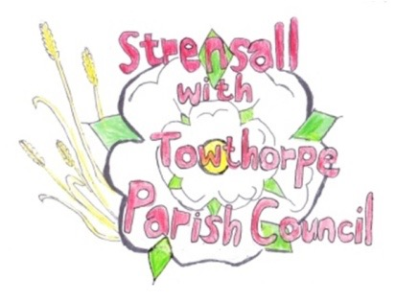
STRENSALL WITH TOWTHORPE PARISH COUNCIL
The Village Hall, Northfields, Strensall, York YO325XW
e-mail: strensalltowthorpePC@outlook.com phone: 01904 491569

NOTICE is hereby given that there will be a Planning Committee meeting of The Parish Council Planning Committee on Tuesday 23rd April 2024 at 6.30pm to be held in the Village Hall for the purpose of transacting the business shown on the Agenda below.
Members of the public and press are welcome to attend
Members of the Council are hereby summoned to attend

AGENDA

1. a) To receive apologies for absence given in advance of the meeting:
b) To consider the approval of reasons given for absence:

2. To receive any declarations of interest under the Parish Council Code of Conduct and Register of Interests

3. To approve the Minutes of 26th March 2024
(The meeting on Tuesday 09th April 2024 was cancelled)

4. To discuss any ongoing issues and information received:

5. To consider and respond to consultations from City of York Council to the planning applications as follows:

- 24/00596/FUL - Single storey side and rear extensions following demolition of existing conservatory @ 14 Barley Rise

- 24/00625/FUL - Raising of ridge height and dormer to rear, and render to side @ 36 Moor Lane

6. To note planning decisions received:

- 24/00106/FUL - Single storey side/rear extensions and render to all elevations @ 2 Fossland View - Approved

7. To confirm the date of the next meeting: - 14th May 2024 at 6.30pm

Fiona Hill - Clerk to the Parish Council 17th April 2024

