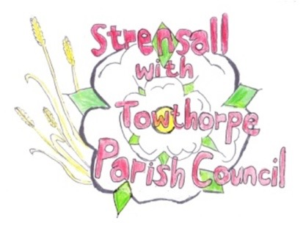
STRENSALL WITH TOWTHORPE PARISH COUNCIL

The Village Hall, Northfields, Strensall, York YO325XW
e-mail: strensalltowthorpePC@outlook.com
phone: 01904 491569
Chairman : Mr A H Fisher

MINUTES OF AN PARISH COUNCIL MEETING HELD IN THE VILLAGE HALL ON TUESDAY 12th MARCH 2024 AT 7.15 PM
Councillors Present: Andrew Bolton Chris Chambers Tony Fisher¹ Lawrence Mattinson Susan Nunn Daniel Pillai
In Attendance: Fiona Hill – Parish Clerk

Public Present: 1 – Graham Green
¹ City of York Councillor

The Chairman gave a tribute to former Parish Councillor Ralph Plant, who recently died, then the Parish Council observed one minutes silence in recognition of his years of service.

- a) To receive apologies for absence given in advance of the meeting: None b) To consider the approval of reasons given for absence: N/A

- To discuss the ordinary and casual vacancies: Graham Green was co-opted to the Parish Council

- To receive any declarations of interest under the Parish Council Code of Conduct or
Members register of interests: Allotment Fence - Cllr Chambers – family member is an allotment holder

- a) To approve the minutes of the Parish Council meeting of 13th February 2024:
Resolved / Approved (Unanimous)
b) To endorse the approved Planning Committee minutes of 13th and 27th February 2024:
Resolved / Endorsed (Unanimous)

- Public participation on any subject relating to the agenda: None

24/101 To receive matters raised by/with City of York Ward Councillors:
a) Network Rail - Construction of two-platform railway station including footbridge, lift towers, staircases, car park, bus turning circle, cycle parking, new foot/cycle path to west of railway and Towthorpe Road and associated works @ Land Adjacent Rail Line At Towthorpe Road (24/00325/FULM) This would be on future agendas, to give the Parish Council and Parishioners the opportunity to study the documents and comment
b) Barratt David Wilson Homes (Yorkshire East) & Vistry Group - Outline application with all matters reserved except for access for circa 800 dwellings, provision of open space, flood storage measures, landscaping and associated infrastructure @ Land To The South Of Rose Cottage Farm And The Lodge Moor Lane Haxby York (23/00160/OUTM) This application had been amended from 800 to 760 dwellings, so the Parish Council would await the new information.
24/102 To discuss and, if necessary, agree action on matters arising/ongoing issues:
a) North Yorkshire Police monthly reports - No report received
b) York Road Garden - See Parish Clerk Report

c) Allotment Fence – Cllr Fisher would speak to the resident
24/103 To discuss and, if necessary, agree action on matters raised since last meeting:

- Purchase of summer flowers for planters:
Resolved / Cllr Nunn could spend up to £250.00 (Unanimous)

- Purchase of Cherry trees, planting and location to be decided:
Cllr Fisher advised the possible Ward funding could be agreed

- Purchase of salt bin on Heath Ride, exact location to be decided:
Cllr Fisher advised the possible Ward funding could be agreed and an ideal location was agreed.

24/104 To discuss and, if necessary, agree action, on any correspondence received: None

24/105 To discuss matters raised by/with Parish Clerk/Responsible Financial Officer (RFO):
- Bank reconciliation, income received, payments made to date:
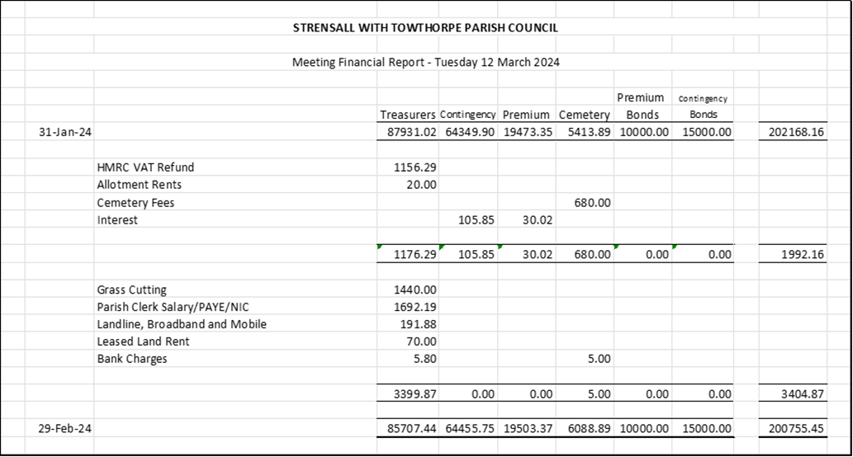
b) Internal Controls Checks: This was conducted by Cllr Fisher and everything found to be in order.
c) Yorkshire Local Councils Association: Information provided was circulated around Cllrs.
d) Payments Approval – None
e) Monthly Report from Parish Office
Royal Name Memorialisation Application – After providing further information, the department replied “Thank you for your email and the information provided. Please note that for Royal names applications, permission is granted (or not granted) upon confirmation of the completion of any proposed projects. I would be grateful if you could please contact the Royal Names Team upon completion of this project in order for the application to be assessed”.
Double Taxation – City of York Council have emailed as follows: “Confirmation that the Strensall Parish Council 2023/24 payment for double taxation will be £12,590.25, As set out below;
Task | Amount of land – sq metres | 2023/24 CYC rate per 1,000m | frequency | Payment  £’s
Triple mower e.g., smaller spaces, play areas, highway verges | 25,227 | £ 12.12 | 10 | 3,057.45
Maintenance of trees, |  |  |  | 4,516.00
Insurance |  |  |  | 2,900.86
war memorial |  |  |  | 1,816.80
Maintenance of play area |  |  |  | 334.00
Other open space works |  |  |  | 300.00
Total payment |  |  |  | 12,590.25

2024/25 Double Taxation - changes to payment rates
Following the decision of the Executive Member for Environment and Climate Emergency on 27th February 2024 I want to let you know the City of York Council will be changing its grass cutting frequencies and future double taxation payment will mirror these changes. General recreation areas, verges and churchyards will now be paid at a rate of 6 cuts per year. Sports and games areas will be paid at a rate of 7 cuts”.
Policies – The checklist has been updated with the review conducted during 2023, which was recorded in the minutes. Before the year end (31Mar24) work will be done to draft/adopt needed policies.
Bench in memory of animals lost in conflicts – On hehalf of the Parish Council, I gave permission for the parishioner to decorate the bench during November 2024, as previous years.
Scattering Ashes – The Parish Council had received an enquiry about scattering ashes in Strensall. The Parish Council would not grant permission for scattering ashes within the cemetery. Ashes could only be interred in a designed plot, subject to the current charges.
24/106 To confirm the date of the next meeting as Tuesday 09th April 2024 at 7.15 p.m.: Resolved / Approved (Unanimous)

