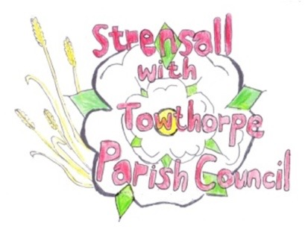
STRENSALL WITH TOWTHORPE PARISH COUNCIL The Village Hall, Northfields, Strensall, York YO325XW e-mail: strensalltowthorpePC@outlook.com phone: 01904 491569
MINUTES OF A PLANNING COMMITTEE MEETING HELD ON TUESDAY 12th MARCH 2024 AT 6.30PM
Councillors Present: Andrew Bolton Chris Chambers Tony Fisher Lawrence Mattison
In Attendance: Fiona Hill - Parish Clerk
Public Present: 1
- a) To receive apologies for absence given in advance of the meeting: None b) To consider the approval of reasons given for absence: N/A

- To receive any declarations of interest under the Parish Council Code of Conduct or
Members register of interests: None

- To approve the minutes of the Planning Committee meeting of 27th February 2024:
Resolved / Approved (Unanimous)

- To discuss any ongoing issues and information received: None

- To consider and respond to consultations from City of York Council to the planning a applications as follows:

- 24/00274/FUL - Single storey side extension following demolition of existing conservatory @ 8 Melcombe Avenue
Resolved – No Objection (Unanimous)

- 24/00299/FUL - Three storey front and rear extensions, two and single storey side extensions, two storey rear extension, 3no. dormers to front, 1no. dormer to rear, juliet balconies to rear and replacement windows throughout @ 9 Oak Tree Close
Resolved – Objection (Unanimous)
Scale and Mass – the extension is too large and not ancillary to the main dwelling.
Street Scene – There are no three storey developments within Oak Tree Close and the only dormers are those originally within bungalow developments.
Terraces - The Planning Application Title describes ‘Juliet’ balconies to the rear. The drawings clearly show and label ‘Terraces’ with the balustrades spanning the full width of the terraces and set some distance from the bedroom windows, meaning that these terraces appear to be occupiable balconies / terraces. A Juliet balcony balustrade should be ‘tight up ‘against the dwelling window and permanently prevent access to an outside area. The plans submitted with balconies / terraces would cause undue harm to the reasonable enjoyment of neighbouring properties by causing an unduly high level of external overlooking and general intrusion into large parts of the neighbouring gardens. The proposed balconies are unacceptable, as they adversely affect the amenity of neighbours and are a contravention of the City of York Council Supplementary Planning Document.
- 24/00378/TCA - Fell 1no. Sycamore - tree in a conservation area @ 5 Church Lane
Resolved – Objection (Unanimous) Due to the prominent aspect in the street scene, the tree should not be felled. The Parish Council would encourage the applicant to explore other methods of tree management.

- To note planning decisions received: None

- To confirm date of the next meeting on Tuesday 26th March 2024 @ 6.30 p.m.
Resolved / Approved (Unanimous)

