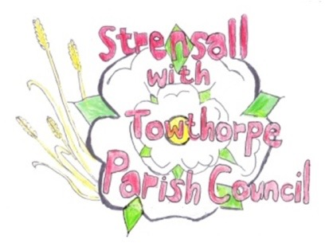
STRENSALL WITH TOWTHORPE PARISH COUNCIL The Village Hall, Northfields, Strensall, York YO325XW e-mail: strensalltowthorpePC@outlook.com phone: 01904 491569

MINUTES OF A PLANNING COMMITTEE MEETING HELD ON TUESDAY 26th MARCH 2024 AT 6.30PM

Councillors Present: Andrew Bolton Chris Chambers Tony Fisher
In Attendance: Fiona Hill - Parish Clerk
Public Present: 1 – Parish Councillor Graham Green

- a) To receive apologies for absence given in advance of the meeting: None b) To consider the approval of reasons given for absence: N/A

- To receive any declarations of interest under the Parish Council Code of Conduct or
Members register of interests: None

- To approve the minutes of the Planning Committee meeting of 12th March 2024:
Resolved / Approved (Unanimous)

- To discuss any ongoing issues and information received: None

- To consider and respond to consultations from City of York Council to the planning a applications as follows:

- 24/00310/FUL – Erection of an agricultural livestock building with a roofed cover @ Lambshill, Towthorpe Moor Lane
Resolved – No Objection, subject to a condition that the building remains for agricultural use only (Unanimous)

- 24/00465/FUL - Installation of an air source heat pump to side @ 85 Moor Lane
Resolved – No Objection, but would suggest the pump would be better sited at the rear of the property, to protect the neighbours amenity and the street view.

- To note planning decisions received: None

Parish Councillor Graham Green accepted an invitation to join the Planning Committee

- To confirm date of the next meeting on Tuesday 09th April 2024 @ 6.30 p.m.
Resolved / Approved (Unanimous)

