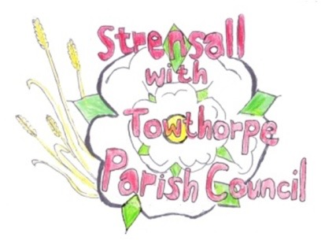 **STRENSALL WITH TOWTHORPE PARISH COUNCIL** The Village Hall, Northfields, Strensall, York YO325XW e-mail: [strensalltowthorpePC@outlook.com](mailto:strensalltowthorpePC@outlook.com) phone: 01904 491569

**MINUTES OF A PLANNING COMMITTEE MEETING HELD ON TUESDAY 14th MAY 2024 AT 6.30PM**

**Councillors Present:** Chris Chambers Tony Fisher Graham Green Lawrence Mattinson

**In Attendance:** Fiona Hill - Parish Clerk

**Public Present:** 0

1. **a) To receive apologies for absence given in advance of the meeting:**

Andrew Bolton **b) To consider the approval of reasons given for absence:** Resolved / Approved (Unanimous)

1. **To receive any declarations of interest under the Parish Council Code of Conduct or**

**Members register of interests:** Cllr Fisher, 24/00645/FUL, has submitted a support comment.

1. **To approve the minutes of the Planning Committee meeting of 23rd April 2024:**

Resolved / Approved (Unanimous)

1. **To discuss any ongoing issues and information received:** None
2. **To consider and respond to consultations from City of York Council to the planning a applications as follows:**
3. 24/00645/FUL – Erection of 1no. two storey dwelling and detached outbuilding after demolition of bungalow and garage @ Ivanhoe, 8 West End Resolved / No Objections, but please take the internal drainage board comments into account (Unanimous)

1. 24/00696/FUL – First floor Juliet balcony to rear and single storey rear extension following demolition of existing conservatory @ 22 Westpit Lane

Resolved / No Objection (Unanimous)

1. **To note planning decisions received:** None

1. **To confirm date of the next meeting on Tuesday 28th May 2024 @ 6.30 p.m.**

Resolved / Approved (Unanimous)