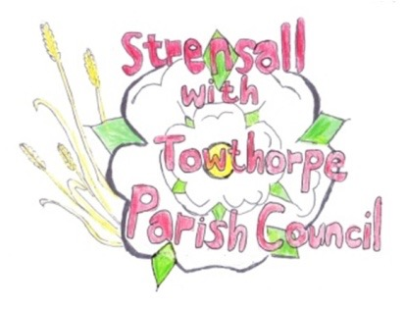 **STRENSALL WITH TOWTHORPE PARISH COUNCIL** The Village Hall, Northfields, Strensall, York YO325XW e-mail: [strensalltowthorpePC@outlook.com](mailto:strensalltowthorpePC@outlook.com) phone: 01904 491569

**MINUTES OF A PLANNING COMMITTEE MEETING HELD ON TUESDAY 23th APRIL 2024 AT 6.30PM**

**Councillors Present:** Andrew Bolton Chris Chambers Tony Fisher

**In Attendance:** Fiona Hill - Parish Clerk

**Public Present:** 0

1. **a) To receive apologies for absence given in advance of the meeting:**

Cllr Mattinson **b) To consider the approval of reasons given for absence:** Resolved / Approved (Unanimous)

1. **To receive any declarations of interest under the Parish Council Code of Conduct or**

**Members register of interests:** None

1. **To approve the minutes of the Planning Committee meeting of 26th March 2024:**

Resolved / Approved (Unanimous) (The meeting on Tuesday 09th April 2024 was cancelled)

1. **To discuss any ongoing issues and information received:** None
2. **To consider and respond to consultations from City of York Council to the planning a applications as follows:**
3. 24/00596/FUL - Single storey side and rear extensions following demolition of existing

conservatory @ 14 Barley Rise Resolved / No Objections (Unanimous)

1. 24/00625/FUL - Raising of ridge height and dormer to rear, and render to side @ 36 Moor Lane

Resolved / Objection (Unanimous) The Parish Council objects to the proposed application on the basis the design of the extension does not appear to be subservient.

The architectural design does not reflect the design of dormers in the area, which are typically set below the roofline.

1. **To note planning decisions received:** 24/00106/FUL - Single storey side/rear extensions and render to all elevations @ 2 Fossland View - Approved

1. **To confirm date of the next meeting on Tuesday 14th May 2024 @ 6.30 p.m.**

Resolved / Approved (Unanimous)