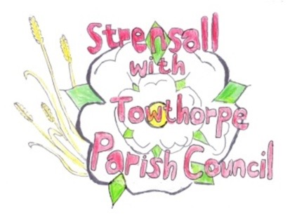 **STRENSALL WITH TOWTHORPE PARISH COUNCIL** The Village Hall, Northfields, Strensall, York YO325XW e-mail: [strensalltowthorpePC@outlook.com](mailto:strensalltowthorpePC@outlook.com) phone: 01904 491569

**MINUTES OF A PLANNING COMMITTEE MEETING HELD ON TUESDAY 28th MAY 2024 AT 6.30PM**

**Councillors Present:** Andrew Bolton Chris Chambers Graham Green

**In Attendance:** Fiona Hill - Parish Clerk

**Public Present:** 0

1. **a) To receive apologies for absence given in advance of the meeting:** Lawrence Mattinson

**b) To consider the approval of reasons given for absence:** Resolved / Approved (Unanimous)

1. **To receive any declarations of interest under the Parish Council Code of Conduct or**

**Members register of interests:** Cllr Bolton, 24/00905/FUL, neighbour.

1. **To approve the minutes of the Planning Committee meeting of 14th May 2024:**

Resolved / Approved (Unanimous)

1. **To discuss any ongoing issues and information received:** None
2. **To consider and respond to consultations from City of York Council to the planning a applications as follows:**
3. 24/00835/TCA – Fell 1no. Diseased Horse Chestnut and remedial prune 1no. Wind damaged Lawsons Cypress – trees in a conservation area @ Manor House Farm, 1 The Village Resolved / No Objections (Unanimous), subject to approval of the Tree Officer and the work should be done by a qualified tree surgeon.

1. 24/00878/FUL – Two storey side and single storey rear extensions @ 15 Shelley Drive

Resolved / Objection (Unanimous), for the reasons as follows:

* Scale and Mass
* Over development of site
* Proximity to neighbouring property

1. 24/00905/FUL – Single storey side extension @ Greensleeves, Lords Moor Lane Resolved / No Objections (Unanimous), But we note the development will sit on the property boundary and has a window overlooking the neighbouring property.

The red line on the location plan, protrudes out from the applicants property, into land in front, which is owned by City of York Council and leased to the Parish Council. This protrusion does not belong to the applicant.

1. **To note planning decisions received:** None

1. **To confirm date of the next meeting on Tuesday 11th June 2024 @ 6.30 p.m.**

Resolved / Approved (Unanimous)