**STRENSALL WITH TOWTHORPE PARISH COUNCIL**

The Village Hall, Northfields, Strensall, York YO325XW

e-mail: [strensalltowthorpePC@outlook.com](mailto:strensalltowthorpePC@outlook.com)

phone: 01904 491569

Chairman : Mr A H Fisher

**MINUTES OF AN PARISH COUNCIL MEETING HELD IN THE VILLAGE HALL ON TUESDAY 14th JANUARY 2025 AT 7.00 PM**

**Councillors Present:** Andrew Bolton Chris Chambers Tony Fisher1 Graham Green Lawrence Mattinson Susan Nunn John Shirbon

**In Attendance:** Fiona Hill – Parish Clerk

**Public Present:** 0

1 City of York Councillor

1. **a) To receive apologies for absence given in advance of the meeting:**  Parish Councillors Alan May and Daniel Pillai **b) To consider the approval of reasons given for absence:** Resolved / Approved (Unanimous)
2. **To discuss the ordinary and casual vacancies:** Currently five
3. **To receive any declarations of interest under the Parish Council Code of Conduct or**

**Members register of interests:** None

1. **a) To approve the minutes of the Parish Council meeting of 10th December 2024:**

Resolved / Approved (Unanimous)

**b) To endorse the approved Planning Committee minutes of 12th November 2024:**

Resolved / Endorsed (Unanimous)

1. **Public participation on any subject relating to the agenda:** None

**24/200 To receive matters raised by/with City of York Ward Councillors:** Cllr Fisher gave an update on the City of York Council budget. Cllr Fisher reported that the Retreat is due to close.

**24/201 To discuss and, if necessary, agree action on matters arising/ongoing issues:** a)North Yorkshire Police monthly reports – Cllrs noted receipt of the December 2024 report.

b) Community Memorial Garden – Governance, Signage, Christmas Tree, Future Planting Costs The Parish Council is still awaiting a draft of the legal document for both leasing and transferring ownership of the land from CYC. Cllrs Nunn and Shirbon gave updates on the work done since the last meeting.

c) Play Areas – Northfields Cone Climber Removal Plan Resolved / The Parish Council accept the offer from Juniper to remove the existing cone climber and install the IP8020 Infinity Bowl and surfacing at a discounted price of £1,237.00.

d) Cordless Pressure Washer – Possible purchase for use on play equipment, benches, signs etc Resolved / Approved (Unanimous)

**24/202 To discuss and, if necessary, agree action, on matters raised since last meetings:**

Emergency Access – Cllrs Bolton and Fisher, along with the Parish Clerk had walked the length of the road. Some pruning of the conifers and the removal of some overgrowth would make the area much better to use. The Parish Council were not minded to take on this work, so would ask City of York Council for their assistance.

Strensall WI would like to donate a Cherry Tree, which the Parish Council gratefully accepted. The location and planting to be confirmed.

**24/203 To discuss matters raised by/with Parish Clerk/Responsible Financial Officer (RFO):**

a) Bank reconciliation, income received, payments made to date:  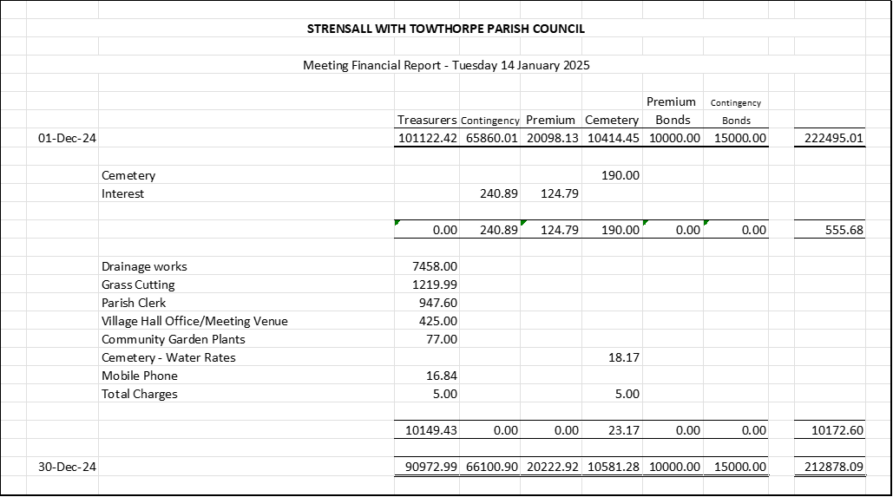

b) Payment Approval: None

c) Financial Management - The interim audit was completed on Wednesday 08th December 2024

d) Yorkshire Local Councils Association: Nothing to report

e) Monthly Report from Parish Office:

**Strensall Common**

A Parishioner emailed as follows:

*“I am writing to seek clarification regarding the use of Strensall Common by local residents and the community, specifically in relation to collecting fallen wood for personal use.*

*As the common is a significant local resource and is grazed by livestock under common rights, I would appreciate your guidance on the following matters:*

1. ***Local By-laws and Community Guidelines****:*
   * *Are there any local by-laws or parish regulations governing the collection of natural materials, such as fallen wood, from Strensall Common?*
   * *If permitted, are there specific procedures or permissions required for such activities?*
2. ***Explicit Restrictions****:*
   * *Are there activities or practices explicitly prohibited on Strensall Common?*
   * *Are there designated areas where access or specific activities are restricted due to environmental concerns, grazing, or other reasons?*
3. ***Community Use****:*
   * *Could you provide an overview of the permitted uses of Strensall Common by local residents and the wider community?*
   * *Are there any historical or current agreements in place that outline the responsibilities of individuals using the common?*

*Additionally, if any maps, documents, or resources are available that outline restricted zones or summarise the regulations for Strensall Common, I would greatly appreciate access to these”.*

The M.O.D. responded as follows:

*“I appreciate that the military site at Strensall is generally referred to by members of Strensall and surrounding villages as “Strensall Common”. I believe it is also referred to that on GOOGLE search!! However, the whole site is owned by the MOD and is private land.*

*The War Office purchased Strensall and Parts of Towthorpe Commons in 1884, they also purchased all Commoners and all other Rights at that time. An Act of Parliament was passed the same year which allows his Majesty’s subject the right to use the said land for recreation and exercise when it is not being used by the MOD personnel for military purposes.*

*When MOD personnel are on the site it is to the full exclusion of everyone else whomsoever. The Site referred to as the “ Strensall Military Training Area” incorporates Queen Elizabeth Barracks (QEB), the Medical Training Centre on Towthorpe Moore Lane, the Ranges and the Open area referred to in the Act as the “Open Ground Land”.*

*The Open Ground Land has also been awarded a National Conservation status of Site of Special Scientific Interest (SSSI) and a European Special Area of Conservation (SAC), this means that any fallen tree or the limb of a tree that break away from the trunk is to be made safe by the site staff and left in the immediate vicinity of the tree for invertebrates, fungus and other flora and fauna to live off.*

*No wood should be removed from any part of the site by members of the public for any reason as this contravenes the Military Byelaws for the site and Ecology and Biodiversity guidelines.*

*Due to the conservation status of the site, the MOD does not allow any type of harvesting of wood, plants, or other foliage to take place at any time. It is also forbidden to conduct any type of shoot in the Open Ground Land, all Live Firing is restricted to the military Range Base and this must be authorised by the range staff in the first instance”.*

**24/204 To confirm the date of the next meeting as Tuesday 11th January 2024 @ 7.00 p.m.:** Resolved / Approved (Unanimous)