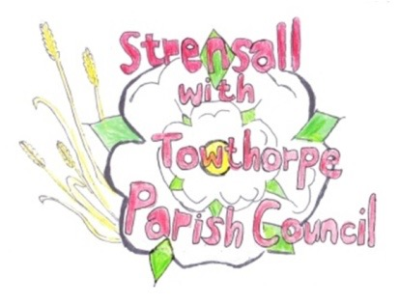 **STRENSALL WITH TOWTHORPE PARISH COUNCIL** The Village Hall, Northfields, Strensall, York YO325XW e-mail: [strensalltowthorpePC@outlook.com](mailto:strensalltowthorpePC@outlook.com) phone: 01904 491569

**MINUTES OF A PLANNING COMMITTEE MEETING HELD ON TUESDAY 11TH FEBRUARY 2025 AT 6.30P.M.**

**Councillors Present:** Andrew Bolton Chris Chambers Tony Fisher Graham Green Lawrence Mattinson

**In Attendance:** Fiona Hill - Parish Clerk

**Public Present:** 0

1. **a) To receive apologies for absence given in advance of the meeting:** None

**b) To consider the approval of reasons given for absence:** N/A

1. **To receive any declarations of interest under the Parish Council Code of Conduct or**

**Members register of interests:** None

1. **To approve the minutes of the Planning Committee meeting of 28th January 2025:**

Resolved / Approved (Unanimous)

1. **To discuss any ongoing issues and information received:** a) 24/02330/FUL – Change of use of paddock into a garden ancillary to new build house with associated boundary treatment @ Middleton House, 2 Redmayne Square Resolved / No Objections (Unanimous) “*Strensall with Towthorpe Parish Council has now established that the land is in the ownership of the applicant, having been sold off from the rest of The Heath.*

*However, the whole of The Heath (formerly a clay extraction site and then a waste disposal site) was designated as Green Open Space in the adopted (15-06-2023) Strensall with Towthorpe Neighbourhood Plan (Appendix 2 pages 56-57). The fact that the parcel of land relevant to this planning application is in private ownership does not affect this designation, as the agent seems to suggest in para 2.1.3 of the planning statement. The designation complies with the criteria in Para 102 of the NPPF as was confirmed by the Planning Inspector who validated the Neighbourhood Plan. The whole area of The Heath was designated as Green Open Space because of its recreational use, landscape value and because of its function as a wildlife corridor from the Foss valley to Strensall Common. Whilst the first criterion does not apply since the application site was fenced off to remove public access, the others still do. In light of this, Strensall with Towthorpe Parish Council does not object to the change of use from paddock to garden, but asks for the following conditions to be applied:*

1. *All permitted development rights to be removed from the area (it is understood that the applicant is agreeable to this). Reason: to maintain the openness of the site and to retain its landscape value.*
2. *The boundary treatment to be porous to allow for the passage of small mammals and amphibians across the site. Reason: to maintain the value of the site as a wildlife transit corridor”.*

*The Parish Council would caution against growing edible fruits and vegetables due to the risk of contamination.*

1. **To consider and respond to consultations from City of York Council to the planning a applications as follows:** 24/02348/FUL – Single storey rear extension @ 14 Fold Walk Resolved / No Objections (Unanimous)

1. **To note planning decisions received:** None

**23/196 To confirm date of the next meeting on Tuesday 25th February 2025 @ 6.30 p.m.** Resolved / Approved (Unanimous)