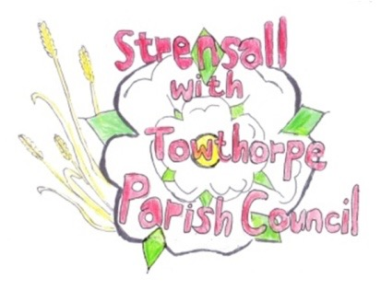 **STRENSALL WITH TOWTHORPE PARISH COUNCIL** The Village Hall, Northfields, Strensall, York YO325XW e-mail: [strensalltowthorpePC@outlook.com](mailto:strensalltowthorpePC@outlook.com) phone: 01904 491569

**MINUTES OF A PLANNING COMMITTEE MEETING HELD ON TUESDAY 25TH MARCH 2025 AT 6.30P.M.**

**Councillors Present:** Andrew Bolton Chris Chambers Tony Fisher Graham Green

**In Attendance:** Fiona Hill - Parish Clerk

**Public Present:** 0

1. **a) To receive apologies for absence given in advance of the meeting:**  Lawrence Mattinson

**b) To consider the approval of reasons given for absence:**  Resolved / Approved (Unanimous)

1. **To receive any declarations of interest under the Parish Council Code of Conduct or**

**Members register of interests:** None

1. **To approve the minutes of the Planning Committee meeting of 11th March 2025:**

Resolved / Approved (Unanimous)

1. **To discuss any ongoing issues and information received:** None
2. **To consider and respond to consultations from City of York Council to the planning a applications as follows:**

a) 25/00389/FUL - 25/00389/FUL - Single storey side extension @ 30 Thompson Drive

Resolved / No Objection (Unanimous)

1. **To note planning decisions received:** None
2. **To confirm date of the next meeting on Tuesday 08th April 2025 @ 6.30 p.m.**

Resolved / Approved (Unanimous)