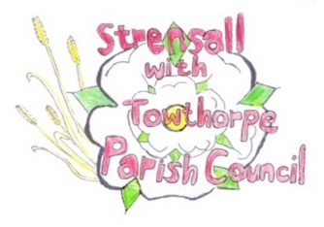 **Strensall with Towthorpe Parish Council**

The Village Hall, Northfields, Strensall, YORK, YO32 5XN.

Tel: 01904 491569 Email: [strensalltowthorpepc@outlook.com](mailto:strensalltowthorpepc@outlook.com) Chairman - Councillor T Fisher

NOTICE is hereby given that there will be a meeting of The Parish Council on **Tuesday 08th April 2025 at 7.00 p.m.** to be held in the Village Hall for the purpose of transacting the business shown on the Agenda below.

Members of the public and press are welcome to attend

Members of the Council are hereby summoned to attend

AGENDA

1a. To receive apologies for absence given in advance of the meeting

1b. To consider the approval of reasons given for absence

(In the unlikely event this meeting is inquorate, the Emergency Governance Committee will deal with the agenda items in accordance with its terms of reference)

2. To discuss the ordinary and casual vacancies

3. To receive any declarations of interest under the Parish Council Code of Conduct or Members register of interests

4a. To approve the minutes of the Parish Council Meeting of 11th March 2025

4b. To endorse the approved Planning Committee minutes of 11th and 25th March 2025

5. Public participation on any subject

- members of the public please note the maximum time for this, in accordance with Standing Orders, is at the discretion of the Chairman and limited to 10 minutes; no person may speak more than once and for no more than 2 minutes. No verbal response will be given but a written response may be requested

6. To receive matters raised by/with City of York Ward Councillors

7. To discuss and, if necessary, agree action on matters arising/ongoing issues

- North Yorkshire Police - monthly report

- Community Memorial Garden – Governance, Planting, Etc

8. To discuss and, if necessary, agree action, on matters raised since last meeting:

- Update of bus shelter outside the Fish & Chip Shop

- City of York Council Consultation – Smoke Control Area for whole of York

9. To discuss matters raised by/with Parish Clerk/Responsible Financial Officer (RFO)

- Bank reconciliation, Receipts and Payments to date

- Payments Approval

- Financial Management

- Policy Review

- Yorkshire Local Councils Association

- Monthly Report from Parish Office

10. To confirm the date of the next meetings as Tuesday 13th May 2025 at –

7.00 p.m. Annual Parish Council Meeting

7.45 p.m. Parish Council Meeting

02th April 2025