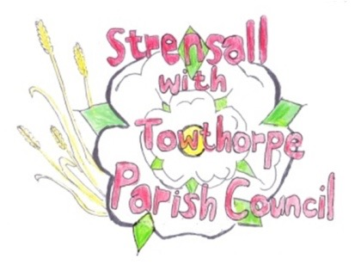**STRENSALL WITH TOWTHORPE PARISH COUNCIL**

The Village Hall, Northfields, Strensall, York YO325XW

e-mail: [strensalltowthorpePC@outlook.com](mailto:strensalltowthorpePC@outlook.com) phone: 01904 491569

NOTICE is hereby given that there will be a Planning Committee meeting of The Parish Council Planning Committee on Tuesday 08th July 2025 at 6.30pm to be held in the Village Hall for the purpose of transacting the business shown on the Agenda below.

Members of the public and press are welcome to attend

Members of the Council are hereby summoned to attend

**AGENDA**

1. a) To receive apologies for absence given in advance of the meeting:

b) To consider the approval of reasons given for absence:

2. To receive any declarations of interest under the Parish Council Code of Conduct and Register of Interests

3. To approve the Minutes of 10th June 2025 (Meeting on 24th June 2025 was cancelled)

4. To discuss any ongoing issues and information received:

5. To consider and respond to consultations from City of York Council to the planning applications as follows:

* 25/01046/FUL - Two storey rear and single storey side extensions @ 6 Adlington Close
* 25/01292/FUL - Single storey rear extension and dormers to side roofslopes @ 10 Church Lane

6. To note planning decisions received:

* 25/00797/FUL - Single storey side and rear extension @ 10 Middlecroft Drive - Approved

7. To confirm the date of the next meeting: - 22nd July 2025 at **6.30pm**

**Fiona Hill** - Clerk to the Parish Council 02nd July 2025