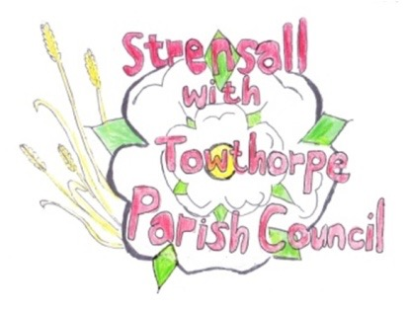 **STRENSALL WITH TOWTHORPE PARISH COUNCIL** The Village Hall, Northfields, Strensall, York YO325XW Email: [strensalltowthorpePC@outlook.com](mailto:strensalltowthorpePC@outlook.com) Telephone: 01904 491569

**MINUTES OF A PLANNING COMMITTEE MEETING HELD ON TUESDAY 10th JUNE 2025 AT 6.30P.M.**

**Councillors Present:** Andrew Bolton Thomas Carmicheal Chris Chambers Tony Fisher Graham Green Lawrence Mattinson

**In Attendance:** Fiona Hill - Parish Clerk

**Public Present:** 0

1. **a) To receive apologies for absence given in advance of the meeting:** None

**b) To consider the approval of reasons given for absence:** N/A

1. **To receive any declarations of interest under the Parish Council Code of Conduct or**

**Members register of interests:** None

1. **To approve the minutes of the Planning Committee meeting of 27th May 2025:**

Resolved / Approved (Unanimous)

1. **To discuss any ongoing issues and information received:** None
2. **To consider and respond to consultations from City of York Council to the planning a applications as follows:**
3. 25/01063/TCA – Fell 1no. Hawthorn (rear garden) – tree in a conservation area @ 27 Southfields Road

Resolved / Object (Unanimous)

The application does not give a reason that felling is necessary. The Parish Council suggests that maintenance and a trim would be more appropriate for an important tree on the street scene, adjacent to a public right of way. The tree is an important pollinator for wildlife.

1. **To note planning decisions received:** 25/00663/FUL – Two storey side and rear extension @ 4 Oaklands - Refused

1. **To confirm date of the next meeting on Tuesday 24th June2025 @ 6.30 p.m.**

Resolved / Approved (Unanimous)