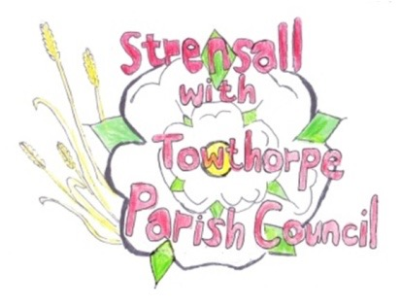 **STRENSALL WITH TOWTHORPE PARISH COUNCIL** The Village Hall, Northfields, Strensall, York YO325XW Email: [strensalltowthorpePC@outlook.com](mailto:strensalltowthorpePC@outlook.com) Telephone: 01904 491569

**MINUTES OF A PLANNING COMMITTEE MEETING HELD ON TUESDAY 27th MAY 2025 AT 6.30P.M.**

**Councillors Present:** Andrew Bolton Chris Chambers Tony Fisher Graham Green Lawrence Mattinson

**In Attendance:** Fiona Hill - Parish Clerk

**Public Present:** 1 – David Dale

1. **a) To receive apologies for absence given in advance of the meeting:** None **b) To consider the approval of reasons given for absence:** N/A

1. **To receive any declarations of interest under the Parish Council Code of Conduct or**

**Members register of interests:** None

1. **To approve the minutes of the Planning Committee meeting of 22nd April 2025:**

Resolved / Approved (Unanimous)

1. **To discuss any ongoing issues and information received:** None
2. **To consider and respond to consultations from City of York Council to the planning a applications as follows:**
3. 25/00663/FUL – Two storey side and rear extension @ 4 Oaklands

Resolved / Objection. The Parish Council strongly objects to this application as contrary to the City of York Council Supplementary Planning Document the large extension is not subservient to the main house. It is a significant overdevelopment of the site, regarding mass. The ridge height of the extension is not lower than the main house and is not set back as recommended in the S.P.D. The Parish Council notes the objection by F.I.D.B, and would wish this to be addressed.

1. 25/00797/FUL Single storey side and rear extension @ 10 Middlecroft Drive

Resolved / Neutral. No Objections

1. 25/00516/TPO – Fell 1 no. Ash tree protected by Tree Preservation Order @ 1 The Birches, Moor Lane

Resolved / Objection. The Parish Council objects to this work, as there is no

professional opinion that the tree either has Ash Die Back or needs felling. The

tree is covered in Ivy, which may be the issue.

1. **To note planning decisions received:** None
2. **To confirm date of the next meeting on Tuesday 27th May 2025 @ 6.30 p.m.**

Resolved / Approved (Unanimous)