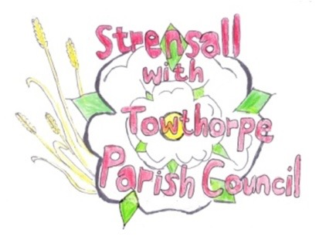 **STRENSALL WITH TOWTHORPE PARISH COUNCIL** The Village Hall, Northfields, Strensall, York YO325XW e-mail: [strensalltowthorpePC@outlook.com](mailto:strensalltowthorpePC@outlook.com) phone: 01904 491569

**MINUTES OF A PLANNING COMMITTEE MEETING HELD ON TUESDAY 22nd APRIL 2025 AT 6.30P.M.**

**Councillors Present:** Andrew Bolton Chris Chambers Tony Fisher Graham Green

**In Attendance:** Fiona Hill - Parish Clerk

**Public Present:** 0

1. **a) To receive apologies for absence given in advance of the meeting:** Lawrence Mattinson

**b) To consider the approval of reasons given for absence:**

Resolved / Approved (Unanimous)

1. **To receive any declarations of interest under the Parish Council Code of Conduct or**

**Members register of interests:** Cllr T Fisher – 25/00632/FUL – had spoken to applicant

1. **To approve the minutes of the Planning Committee meeting of 08th April 2025:**

Resolved / Approved (Unanimous)

1. **To discuss any ongoing issues and information received:** None
2. **To consider and respond to consultations from City of York Council to the planning a applications as follows:**
3. 25/00597/FUL - Use of existing hardstanding on land to touring caravan park for the storage of caravans @ Country Park, Pottery Lane

Resolved / Objection, as this application should be refused for the same reasons as 23/00996/FUL and appeal decision APP/C2741/W/23/3335577 (23/00048/REF), as no change in circumstances have been demonstrated.

It is an inappropriate development in the green belt and the Parish Council asks City of York Council to commence enforcement action accordingly.

1. 25/00632/FUL - Variation of conditions 2 of permitted application 24/00645/FUL to alter the proposed plans and elevations and removal of condition 3 @ Ivanhoe, 8 West End

Resolved / No Objection, but the Parish Council questions why condition 3 should be removed, rather than the condition being ongoing until the condition is discharged satisfactorily.

1. 25/00752/TCA - Reduce the height of Lawson Cypress Group to approximately 3 metres from ground level and lateral prune; Leylandii tree group - cut all over hanging vegetation back to the boundary fence line and reduce the height to approximately 3 metres; Reduce the canopy height of 1no. Lilac Tree by approximately 1 metre and lateral prune; Reduce all over hanging branch work to 1no. Ash Tree back to the boundary fence - tree works in a Conservation Area @ 1 Moor Lane

Resolved / No Objection, subject to guidance from the City of York Council Tree

Officer and the work should be done outside the bird nesting season.

1. **To note planning decisions received:**

a)25/00151/FUL – Two storey extension to detached garage/home office @ 18 Moor Lane - Approved

1. **To confirm date of the next meeting on Tuesday 14th May 2025 @ 6.30 p.m.**

Resolved / Approved (Unanimous)