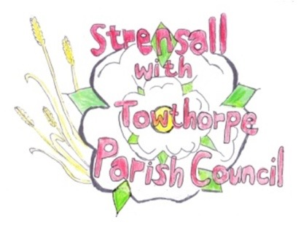 **STRENSALL WITH TOWTHORPE PARISH COUNCIL** The Village Hall, Northfields, Strensall, York YO325XW Email: [strensalltowthorpePC@outlook.com](mailto:strensalltowthorpePC@outlook.com) Telephone: 01904 491569

**MINUTES OF A PLANNING COMMITTEE MEETING HELD ON TUESDAY 10th JUNE 2025 AT 6.30P.M.**

**Councillors Present:** Andrew Bolton Thomas Carmicheal Chris Chambers Tony Fisher Graham Green Lawrence Mattinson

**In Attendance:** Fiona Hill - Parish Clerk

**Public Present:** 0

1. **a) To receive apologies for absence given in advance of the meeting:** None

**b) To consider the approval of reasons given for absence:** N/A

1. **To receive any declarations of interest under the Parish Council Code of Conduct or**

**Members register of interests:** None

1. **To approve the minutes of the Planning Committee meeting of 27th May 2025:**

Resolved / Approved (Unanimous)

1. **To discuss any ongoing issues and information received:** None
2. **To consider and respond to consultations from City of York Council to the planning a applications as follows:**
3. 25/01063/TCA – Fell 1no. Hawthorn (rear garden) – tree in a conservation area @ 27 Southfields Road

Resolved / Object (Unanimous)

The application give no reason by felling is necessary. The Parish Council suggests maintenance and trim would be more appropriate for an important tree on the street scene, adjacent to a public right of way. The tree is an important pollinator for wildlife.

1. **To note planning decisions received:** 25/00663/FUL – Two storey side and rear extension @ 4 Oaklands - Refused

1. **To confirm date of the next meeting on Tuesday 24th June2025 @ 6.30 p.m.**

Resolved / Approved (Unanimous)