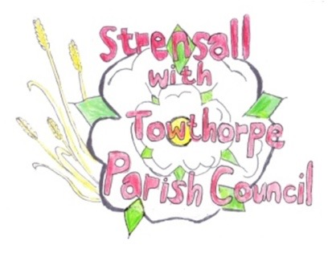**STRENSALL WITH TOWTHORPE PARISH COUNCIL**

The Village Hall, Northfields, Strensall, York YO325XW

e-mail: [strensalltowthorpePC@outlook.com](mailto:strensalltowthorpePC@outlook.com) phone: 01904 491569

NOTICE is hereby given that there will be a Planning Committee meeting of The Parish Council Planning Committee on **Tuesday 12th August 2025** at **6.30pm** to be held in the Village Hall for the purpose of transacting the business shown on the Agenda below.

Members of the public and press are welcome to attend

Members of the Council are hereby summoned to attend

**AGENDA**

1. a) To receive apologies for absence given in advance of the meeting:

b) To consider the approval of reasons given for absence:

2. To receive any declarations of interest under the Parish Council Code of Conduct and Register of Interests

3. To approve the Minutes of 08th July 2025 (Meeting cancelled on 22nd July 2025)

4. To discuss any ongoing issues and information received:

5. To consider and respond to consultations from City of York Council to the planning applications as follows:

1. 25/01424/FUL - Single storey side and rear extension @ 68 Barley Rise
2. 25/01458/TPO - Reduce the branch work extending into garden by approximately 2.4 meters and removal of one damaged limb of 1no. Oak protected by Tree Preservation Order CYC 285 @ 16 Heath Ride
3. 25/01488/FUL - Pitched roof to existing garage, conversion of detached garage to habitable space, timber fence to boundary perimeter and new access driveway gates @ 4 Newton Way
4. 25/01536/TCA - Remove large branch overhanging 61 The Village from 1no. Ash (located at 67 The Village)  - tree in a conservation area @ Aleppo, 67 The Village

6. To note planning decisions received:

a) 25/00632/FUL - Variation of conditions 2 of permitted application 24/00645/FUL to alter the proposed plans and elevations and removal of condition 3 @ Ivanhoe, 8 West End - Approved

b) 25/00878/FUL - Two storey side extension, render to front elevation, new portico and alterations to windows to front after removal of porches to front and side @ 33 Southfields Road - Approved

c) 25/00910/FUL - Replacement of existing open steel mesh gates to the south porch of church with new high quality oak and glass doors @ St Marys Church, Church Lane - Approved

d) 25/00931/FUL - Single storey side and rear extension, porch to front, replacement windows and render and re-cladding of existing dormers @ 4 Moorland Garth - Approved

e) 25/01063/TCA - Fell 1no. Hawthorn (rear garden) - tree in a conservation area @ 27 Southfields Road - Consented

7. To confirm the date of the next meeting: - 26th August 2025 at 6.30pm

**Fiona Hill** - Clerk to the Parish Council 06th August 2025