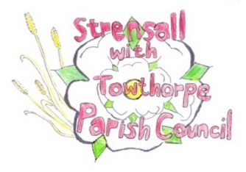 **Strensall with Towthorpe Parish Council**

The Village Hall, Northfields, Strensall, YORK, YO32 5XN.

Tel: 01904 491569 Email: [strensalltowthorpepc@outlook.com](mailto:strensalltowthorpepc@outlook.com) Chairman - Councillor T Fisher

NOTICE is hereby given that there will be a meeting of The Parish Council on **Tuesday 12th August 2025 at 7.00 p.m.** to be held in the Village Hall for the purpose of transacting the business shown on the Agenda below.

Members of the public and press are welcome to attend

Members of the Council are hereby summoned to attend

AGENDA

1a. To receive apologies for absence given in advance of the meeting

1b. To consider the approval of reasons given for absence

(In the unlikely event this meeting is inquorate, the Emergency Governance Committee will deal with the agenda items in accordance with its terms of reference)

2a. To discuss the vacancy

2b. To invite recently co-opted members to join committees

3. To receive any declarations of interest under the Parish Council Code of Conduct or Members register of interests

4a. To approve the minutes of the Parish Council Meeting of 08th July 2025

4b. To endorse the approved Planning Committee minutes of 08th July 2025

5. Public participation on any subject

- members of the public please note the maximum time for this, in accordance with Standing Orders, is at the discretion of the Chairman and limited to 10 minutes; no person may speak more than once and for no more than 2 minutes. No verbal response will be given but a written response may be requested

6. To receive matters raised by/with City of York Ward Councillors

7. To discuss and, if necessary, agree action on matters arising/ongoing issues

- North Yorkshire Police - monthly report

- Community Memorial Garden – Governance, Planting, Etc

- Play Areas – Rocking Horse, RoSPA Inspection 2025

8. To discuss and, if necessary, agree action, on matters raised since last meeting:

- CYC - Opposed order - Public Footpaths Westpit Strensall Modification Order 2022 - CYC – Drainage Inspections Lords Moor Lane to War Memorial – July 2025 - Rotten fence between village hall car park and play area - Handyman Update - New Bus Shelter outside Strensall Fisheries – location with litter bin

9. To discuss matters raised by/with Parish Clerk/Responsible Financial Officer (RFO) - Bank reconciliation, Receipts and Payments to date - Payments Approval - Financial Management - Policy Review - Yorkshire Local Councils Association - Monthly Report from Parish Office

10. To confirm the date of the next meeting as Tuesday 09th September 2025 at 7.00 p.m.

06th August 2025