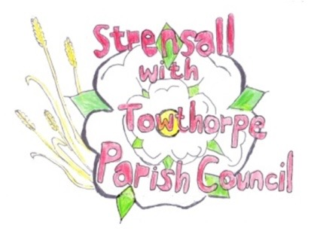 **STRENSALL WITH TOWTHORPE PARISH COUNCIL** The Village Hall, Northfields, Strensall, York YO325XW Email: [strensalltowthorpePC@outlook.com](mailto:strensalltowthorpePC@outlook.com) Telephone: 01904 491569

**MINUTES OF A PLANNING COMMITTEE MEETING HELD ON TUESDAY 08th JULY 2025 AT 6.30P.M.**

**Councillors Present:** Andrew Bolton Chris Chambers Tony Fisher Graham Green Lawrence Mattinson

**In Attendance:** Fiona Hill - Parish Clerk

**Public Present:** 0

1. **a) To receive apologies for absence given in advance of the meeting:** Thomas Carmicheal

**b) To consider the approval of reasons given for absence:** Resolved / Approved (Unanimous)

1. **To receive any declarations of interest under the Parish Council Code of Conduct or**

**Members register of interests:** None

1. **To approve the minutes of the Planning Committee meeting of 10th June 2025:**

Resolved / Approved (Unanimous) (Meeting on 24th June 2025 was cancelled)

1. **To discuss any ongoing issues and information received:** None
2. **To consider and respond to consultations from City of York Council to the planning a applications as follows:**
3. 25/01046/FUL – Two storey rear and single storey side extensions @ 6 Adlington Close

Resolved / Neutral, No Objections (Unanimous)

1. 25/01292/FUL – Single storey rear extension and dormers to side roof slopes @ 10 Church Lane

Resolved / Neutral, No Objections (Unanimous)

1. **To note planning decisions received:** 25/00797/FUL – Single storey side and rear extension @ 10 Middlecroft Drive - Approved

1. **To confirm date of the next meeting on Tuesday 22nd July 2025 @ 6.30 p.m.**

Resolved / Approved (Unanimous)