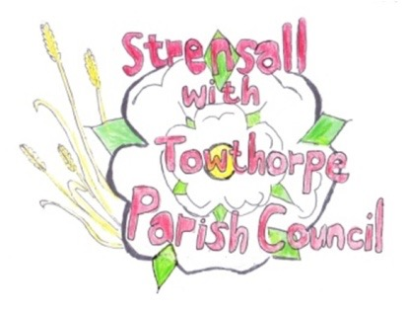**STRENSALL WITH TOWTHORPE PARISH COUNCIL**

The Village Hall, Northfields, Strensall, York YO325XW

e-mail: [strensalltowthorpePC@outlook.com](mailto:strensalltowthorpePC@outlook.com) phone: 01904 491569

NOTICE is hereby given that there will be a Planning Committee meeting of The Parish Council Planning Committee on **Tuesday 09th September 2025** at **6.30pm** to be held in the Village Hall for the purpose of transacting the business shown on the Agenda below.

Members of the public and press are welcome to attend

Members of the Council are hereby summoned to attend

**AGENDA**

1. a) To receive apologies for absence given in advance of the meeting:

b) To consider the approval of reasons given for absence:

2. To receive any declarations of interest under the Parish Council Code of Conduct and Register of Interests

3. To approve the Minutes of 12th August 2025 (Meeting cancelled on 26thd August 2025)

4. To discuss any ongoing issues and information received:

5. To consider and respond to consultations from City of York Council to the planning applications as follows:

1. 25/01616/TPO - Crown lift 1no. Oak to 5.2m above ground level to over highway and up to 1m lateral reduction of crown over driveway - tree protected by Tree Preservation Order 189A @ The Oak 46 Moor Lane
2. 25/01640/FUL - Single storey rear extension @ 15 Littlethorpe Close
3. 25/01656/TCA – Fell 1no. Christmas tree (rear garden) - tree in a conservation area @ The Coach House, Southfields Road
4. 25/01713/TCA - Fell 1no. Silver Birch (rear gdn)  - tree in a conservation area @ The Stables, 70 The Village

6. To note planning decisions received:

1. 25/01046/FUL - Two storey rear and single storey side extensions @ 6 Adlington Close - Approved
2. 25/01281/FUL - Single storey rear extension @ 4 Chapman Close - Approved
3. 25/01384/FUL - Partial conversion of garage into habitable space with associated external alterations @ Church Farm 15 Church Lane - Approved

7. To confirm the date of the next meeting: - 23rd September 2025 at 6.30pm

**Fiona Hill** - Clerk to the Parish Council 03rd September 2025