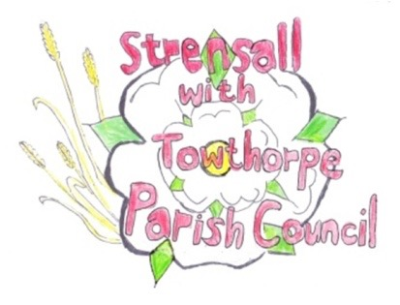
STRENSALL WITH TOWTHORPE PARISH COUNCIL
The Village Hall, Northfields, Strensall, York YO325XW
e-mail: strensalltowthorpePC@outlook.com phone: 01904 491569

NOTICE is hereby given that there will be a Planning Committee meeting of The Parish Council Planning Committee on Tuesday 11th November 2025 at 6.30pm to be held in the Village Hall for the purpose of transacting the business shown on the Agenda below.
Members of the public and press are welcome to attend
Members of the Council are hereby summoned to attend

AGENDA

1. a) To receive apologies for absence given in advance of the meeting:
b) To consider the approval of reasons given for absence:

2. To receive any declarations of interest under the Parish Council Code of Conduct and Register of Interests

3. To approve the Minutes of 28th October 2025
4. To discuss any ongoing issues and information received:

5. To consider and respond to consultations from City of York Council to the planning applications as follows:

- 25/02114/TPO - Crown lift to 3m above ground level of 1no. Oak protected by Tree Preservation Order CYC 30 @ 6 Brunswick Close

6. To note planning decisions received:

- 25/01616/TPO - Crown lift 1no. Oak to 5.2m above ground level to over highway and up to 1m lateral reduction of crown over driveway - tree protected by Tree Preservation Order 189A @ The Oak 46 Moor Lane – No Objections

7. To confirm the date of the next meeting: - 25th November 2025 at 6.30pm

Fiona Hill - Clerk to the Parish Council 05th November 2025

