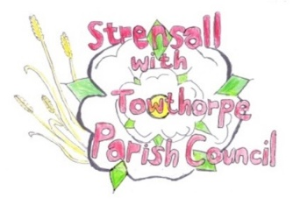
Strensall with Towthorpe Parish Council

The Village Hall, Northfields, Strensall, YORK, YO32 5XN.
Tel: 01904 491569 Email: strensalltowthorpepc@outlook.com Chairman - Councillor T Fisher

NOTICE is hereby given that there will be a meeting of The Parish Council on Tuesday 11th November 2025 at 7.00 p.m. to be held in the Village Hall for the purpose of transacting the business shown on the Agenda below.
Members of the public and press are welcome to attend
Members of the Council are hereby summoned to attend

AGENDA

1a. To receive apologies for absence given in advance of the meeting
1b. To consider the approval of reasons given for absence
(In the unlikely event this meeting is inquorate, the Emergency Governance Committee will deal with the agenda items in accordance with its terms of reference)

2. To receive any declarations of interest under the Parish Council Code of Conduct or Members register of interests

3a. To approve the minutes of the Parish Council Meeting of 14th October 2025
3b. To endorse the approved Planning Committee minutes of 14th and 28th October 2025

4. Public participation on any subject
- members of the public please note the maximum time for this, in accordance with Standing Orders, is at the discretion of the Chairman and limited to 10 minutes; no person may speak more than once and for no more than 2 minutes. No verbal response will be given but a written response may be requested

5. To receive matters raised by/with City of York Ward Councillors

6. To discuss and, if necessary, agree action on matters arising/ongoing issues
- Northfields Trees Inspection Report – Urgent/High Priority
- Play Area Weekly Inspections – Previous Month Report/Next Month Nominate Councillor

7. To discuss and, if necessary, agree action, on matters raised since last meeting:
- Christmas Together – Grant Request
- City of York Council – Annual Review of Traffic Restriction Statutory Consultation – No Waiting at any time restrictions in Kirklands
- Parish Office – Monthly Report

8. To confirm the date of the next meeting as Tuesday 09th December 2025 at 7.00 p.m.

05th November 2025

