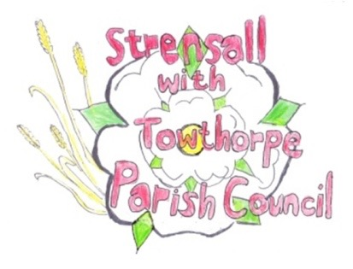
STRENSALL WITH TOWTHORPE PARISH COUNCIL
The Village Hall, Northfields, Strensall, York YO325XW
e-mail: strensalltowthorpePC@outlook.com phone: 01904 491569

NOTICE is hereby given that there will be a Planning Committee meeting of The Parish Council Planning Committee on Tuesday 13th January 2026 at 6.30pm to be held in the Village Hall for the purpose of transacting the business shown on the Agenda below.
Members of the public and press are welcome to attend
Members of the Council are hereby summoned to attend

AGENDA

1. a) To receive apologies for absence given in advance of the meeting:
b) To consider the approval of reasons given for absence:

2. To receive any declarations of interest under the Parish Council Code of Conduct and Register of Interests

3. To approve the Minutes of 23rd December 2025
4. To discuss any ongoing issues and information received:

5. To consider and respond to consultations from City of York Council to the planning applications as follows:

- 25/02490/CLD - Certificate of lawfulness for existing development 3no. amenity buildings ancillary to touring caravan site @ Country Park, Pottery Lane

6. To note planning decisions received:

- 25/01851/FUL - Single storey rear extension and detached garage conversion to habitable space @ 25 Westpit Lane – Approved
- 25/01935/TCA - Reduce Leylandii group to 3-4m above ground level - trees in a conservation area @ Grange Hill 61 The Village - Consented

7. To confirm the date of the next meeting: - 27th January 2026 at 6.30pm

Fiona Hill - Clerk to the Parish Council 07th January 2026

